



Team 22

Team Optimum

Robert Mulligan • Alex Ingoglia • James Yaury • Jifang Wang • Aaron Kasper • Kendall Sullivan

TABLE OF Contents

Executive Summary 3

Management 7

Mission, Vision & Goals 8

Staffing Forecast 13

Compensation 16

Performance Management 22

Recruitment 26

Organizational Design 29

Leadership Appendix 33

Marketing 56

Evaluating PERSCON vs. Competition 56

Segmentation 57

Positioning 60

Evaluation Distribution Channels 62

Promotion Decisions 67

Pricing P911 ERD 70

Global Marketing Strategy 72

Marketing Appendix 75

Operations 81

Capacity Management 81

Order Policy 82

Project Management 84

Quality Management 85

Supper Selection 88

Operations as a Value Added Function 89

Operations Appendix 93

Finance 102

Overview 102

Project β 102

Cost of Capital 103

Incremental Cash Flow & NPV 103

Project Conclusion 105

Mr.Nimmo’s Concerns 105

Finance’s Value Added 108

# Executive Summary

Our team recommends PERSCON to move forward with the P911 ERD. By analyzing from a financial, operational, marketing, and managerial viewpoint, we have uncovered that the launch of the P911 ERD offers a positive outcome for our company and shareholders. This report portrays our in-depth analysis of each functional area and provides a strategy for implementing a successful product into the market.

As the PERS market continues to grow, we anticipate consumer’s need for an improved extended range device; therefore, the P911 ERD is a profitable venture for PERSCON to undertake. Our team recommends pursuing the project due to its strong financial potential and ability to advance our company as a whole. Financially, the project’s high NPV makes it attractive; however, undertaking this project will also aid the firm’s operational growth, marketing expansion, and development of company culture.

PERSCON’s employees have reached a state of complacency, content with our company’s stagnant position in the market. As a result, shareholders worry about the stock price’s growth. PERSCON’s market share has plateaued around 5% for the last four years. Operationally, we need to cut costs and improve quality. We recommend forward-thinking ideas to re-motivate employees, increase stock growth, access market share and market growth opportunities, and cut unnecessary operational costs while maintaining quality. These benefits begin with investing in the expedited launch of the P911 ERD.

The P911 ERD grants us the ability to expand into new psychographic and geographic markets. By using operations management to crash the P911 ERD launch, the product will be ready in time for the Thai trade show. At the trade show, our company can impress foreign investors, build relationships, and in the long-run, move towards forming joint ventures with Taiwanese companies for expansion overseas.

The P911 ERD also provides potential growth in our domestic market. A new promotional plan targets young women, assisted living centers, outdoors adventurers, and anyone sophisticated about safety. A new website, social media presence, and consumer relationship management system will help PERSCON build stronger relationships with customers. The PERSCON brand, known for our industry-leading reliability and customer service, will build even more equity through these new marketing channels and a stronger connection with consumers.

In an attempt to increase market share, the new product will be priced with a penetration strategy and a “more for less” value proposition. We also suggest adding price bundling to the current captive pricing strategy. By offering discounts on activation fees with more subscriptions per account, PERSCON will increase the volume of our main profit-raising dimension: monthly subscriptions. With more customers and better relationships, our quest for quality becomes even more vital.

To ensure PERSCON’s guarantee on reliability and service remains untarnished, we have reevaluated some of our operational norms. This report identifies the most cost efficient supplier that permits us to offer the highest possible quality to customers. Furthermore, we calculate the costs of expediting the launch of the P911 ERD to be ready for the tradeshow. After evaluating labor costs, we discovered that the optimal way to assemble and repair our product uses a complete worker-paced system.

By building quality into our internal processes, rather than 100% inspection of finished goods, quality becomes free. We can save money from replacing defective products less frequently. Value is added by investing more in prevention towards the start of the process, and in turn, we minimize the chance of internal and external failure. This, along with other inefficient, costly operational norms are addressed in this report. The outdated practices do not stop at an operational level.

PERSCON has grown without structure since its inception; operating without strategy, goals, and company-wide practices. This report suggests a new mission and vision statement as well as concrete goals for the upcoming year. The gainsharing programs and bonus system suggested for manufacturers, customer service representatives, and responders will shake employees out of complacency and into a brand new company culture. The suggested recruitment and performance management plans focused on quality of service will enhance employees’ happiness, training, and abilities.

Although we are ready to market the P911 ERD unit through a new promotional campaign with a word hook, consistent character, and consistent theme, our team suggests waiting three years before separating the P911 ERD unit on an organizational level. The emergency response center staff-forecasts of a separate P911 ERD unit show a low necessity to create a stand-alone unit; the increase in subscriptions from the P911 ERD will require only one additional customer service representative. Although, a human resources department is well overdue and will be especially necessary with the new product launch.

As with any new product launch, our company will take on brand reputation, managerial, and operational risks that could damage our company financially:

Our team identified the two biggest risks as market development and defective products. With a new market, we take on risks that our brand will not accurately resonate with our additional segments. An expansion of our brand overseas poses a managerial and marketing risk towards an untapped culture. Once we expand into these new markets, PERSCON runs the risk of ruining brand equity with defective products as the extended range device is harder to manage. Both of the potential suppliers pose risks of defective products, which could lead to a lawsuit.

Insufficient capacity because of the uncertainty of demand also poses a risk. Demand for the P911 ERD is projected at 7,500 units; however, if we do not have the capacity to fill high demand, our reliable reputation and same-day repair policy is in jeopardy. We hedged this risk by making low-medium-high predictions for demand.

The last two risks our team identified are opportunity costs and resilient employees. This project will change other product’s sales, some for better and some for worse. Another opportunity costs we face is the possibility to invest in a mutual fund; we have the opportunity to invest in the market rather than this project. If this product fails financially, employees will experience more work for the same wage rate (job enlargement). Employees might also be resilient to new strategies and a culture change because they are loyal to the norms of the company and complacent.

Marketing could also affect management. If our marketing is successful beyond our operational demand estimates, our staffing forecasts will be deficient. The length and thoroughness of the recruitment process could leave current employees with an overflow of calls before the extra emergency response center employee is hired. This could lead to increased call waiting for customer service representatives and missed calls by responders.

Similarly, decided prices by marketing could lower the project’s NPV. If the customer perceived value is lower than our planned price, sales will suffer. Therefore, marketing and finance must work together to decide upon a price and predicted cash flows. If operations is not effective in crashing the project in time for the trade show, our overseas marketing would be nonexistent, and we relinquish our opportunity for a future joint venture.

We assess all of the risks in the following report and we remain confident that we should invest in the P911 ERD. The value added by cutting operational costs, developing a new market, generating a positive return on our investment, and a proper organizational structure are a few of the overarching benefits as a result of pursuing this project. Our report offers recommendations to move forward with this project for the managerial, marketing, operational, and financial divisions of the firm for a successful launch.

# Management

## Mission, Vision & Goals

**Mission**

At PERSCON, we are health care professionals who use innovation and top-notch quality to deliver safety through emergency response devices to those who must handle life’s curveballs. We answer all your emergency calls because we all have someone we care about.

Good mission and vision statements effectively show a company’s core values and strategy. They should reflect the beliefs, traits, and behavioral norms that the company expects from its employees, helping to mold and keep the culture of the firm. Some of PERSCON’s core values are customer experience, innovation, and compassion. While keeping these values in mind, the company seeks to enter a new market (global expansion) and a new psychographic (active lifestyle).

An effective mission statement reflects where a company stands today while answering the questions who we are, what we do, why are we here, who we serve ad how we serve them. Microsoft, for example, shows core values while answering all the necessary questions. Their mission statement claims, “At Microsoft, we work to help people and businesses throughout the world realize their full potential. This is our mission. Everything we do reflects this mission and the values that make it possible” (“Fortune”). This answers who they are (“Microsoft”), what they do (“help people and businesses…realize their full potential”), why they do it (their values), and who they serve (“people and businesses”). Starbucks, on the other hand, has an ineffective mission statement: “Our mission: to inspire and nurture the human spirit – one person, one cup and one neighborhood at a time” (“Fortune”). It reflects what they do (inspire and nurture the human spirit) and how they do it (“one person, one…at a time), but completely neglects the why.

We recommend the mission statement: “At PERSCON, we are health care professionals who use innovation and top-notch quality to deliver safety through emergency response devices to those who must handle life’s curveballs. We answer all your emergency calls because we all have someone we care about.” The statement delivers the core values of innovation and quality while answering all the questions. Readers, potential investors, and employees can see exactly who we are (“PERSCON”, “health care professionals”), what we do (“deliver safety”), how we do it (“through emergency response devices”, “We answer all your emergency calls”), why we do it (“because we all have someone we care about”), and whom we serve (“those who must handle life’s curveballs”). By including the phrase “top-notch quality” the statement reflects our industry-leading customer service. The mission even alludes to the company’s founding. Art Smith cared for his parents who refused to be put in a home; thus, he sought to improve the PERS industry for them. PERSCON now operates because, like Smith, we all have someone we care about.

**Vision**

To become the world’s most reliable invisible guardian – whatever lifestyle you pursue.

The vision statement, on the other hand, should be concise, graphic, focused, memorable, and relevant for goal setting. Effective vision statements communicate top management’s views about the future while separating the firm from its competition. For example, Wal-Mart and Trader Joe’s have virtually opposite vision statements because the former is focused on cutting cost while the latter attempts to carry the most popular products, regardless of price.

Although their mission statement is sub-par, Starbucks has an effective vision statement: “To be the world’s largest provider of high-quality coffee” (Company Mission and Strategic Goals Lecture). It is graphic, focused, feasible, and memorable. It also sets itself apart from competition by being the “world’s largest” and serving “high-quality coffee.” Lastly, it sets goals of global expansion and leadership.

A bad vision statement is vague, present-focused, long, bland, and uninspiring. For example, "GM’s vision is to be the world leader in transportation products and related services. We will earn our customers’ enthusiasm through continuous improvement driven by the integrity, teamwork, and innovation of GM people" (Quintela). Although GM’s vision statement may be forward-looking and inspiring, it sounds more like a mission statement for its vague, bland qualities and length.

We recommend the vision statement: “To become the world’s most reliable invisible guardian – whatever lifestyle you pursue.” This statement uses graphic words and phrases while focusing on customer safety. This vision is memorable for its use of allusions like “invisible guardian” and effective use of a hyphen. By using the phrase “most reliable,” the statement sets PERSCON apart from competitors such as NAP, who lack a GPS, and AMCON, who has suffered in quality. The goals include targeting customers with active lifestyles, while staying with senior citizens and setting the stage for possible global expansion.

Our recommended statements mesh together to form a cohesive strategy of expansion while retaining quality and reliability standards. These two statements alone could revitalize and motivate the workforce out of complacency by setting new standards and targets. Most importantly, they build a culture for innovation and improved quality of customer service.

**Balanced Scorecard**

The P911 ERD shows potential to make strides in company finances, customer service, international business processes, and learning and growth. PERSCON’s goals must stay specific, measurable, attainable, relevant, and time bound (SMART). Using SMART goals and a balanced scorecard will guide PERSCON towards effective implementation of vision and strategy. Our company goals will also help organize work efforts, motivate employees, and assist company culture.

Consistent with the corporate strategy, we stress customer focused goals. The scorecard asks, “To achieve our vision, how should we appear to our customers?” The answer to this question smoothly extends from our proposed mission statement, vision statement, and core values. We prioritize *customer service*, *compassion*, and *reliability*. The customer service quality rates well at 4.6/5, but customers are frustrated with call time at a low 2.9/5 rating. The first SMART goal for customers is to decrease wait time on service calls by 17% (30 seconds) for the P911 ERD over the next year.

* Specific: Reduce wait time by 30 seconds
* Measurable: Compare to the past “wait time” rating
* Attainable: Achievable through increased automation and higher technology proficiency
* Relevant: Wait time on service calls remains the biggest criticism PERSCON gets about service
* Time bound: To be completed over the next year

Another way to accomplish this goal includes collecting better data about call volume and changing the schedule to increase the number of customer service reps in the 9 AM-2 PM hours.

As for the learning and growth metric of the scorecard, we focus on a SMART goal that also improves the customer metric. We plan to develop a bonus program that rewards responders for furthering their education on both healthcare and customer service, and thus quality ratings, by the end of the year. This strategy is described in depth in the “Compensation” section; however, the goal is:

* Specific: Addresses education and quality ratings for responders
* Measurable: By their quality ratings
* Attainable: Representatives have enough leisure time for cross-word puzzles and surfing the web
* Relevant: Quality of customer service is of the utmost importance to PERSCON
* Time bound: We will compare scores from the time of the start of the goal to the end of the year

With the new product, we expect results, specifically an increase in stock price. Shareholders currently worry that the company is slowing down financially, so setting a goal to please them is pressing. Currently, the stock’s growth rate reports at about 1% per month (or 12% per year). To reverse the trend and start increasing the stock’s growth again, we suggest a SMART goal to grow stock price by 15% a year after the P911ERD’s launch.

* Specific: Increase stock price
* Measurable: Can measure increase each quarter
* Attainable: With the new product, we expect results, specifically an increase in stock price
* Relevant: Shareholders have placed pressure on upper management about stock price growth
* Time bound: To be completed a year after the new product’s launch

Lastly, the international business processes metric is completely reliant upon our ability to impress potential partners at the upcoming trade show. For the SMART goal for this metric, we aspire to complete the P911 ERD launch in 27 weeks.

* Specific: To our new product’s launch time
* Measurable: The operations department will be able to determine the projected finish date
* Attainable: Through crashing
* Relevant: We plan to unveil the product on the global scale at this trade show
* Time bound: It must be done in 27 weeks

By focusing on these four SMART goals, PERSCON can stay consistent with our vision and strategy, while measuring progress every step of the way. By actually setting these SMART goals, historic data shows we have an 80% better chance to achieve them.

## Staffing Forecast

**Employee Forecasts with 5% Growth**

The work for the following forecasting can be found in the Appendix (Exhibit Z1).

Since current responders work 24/7/365, the “Full Time Employee (FTE) paid hours” are 40 hours per week multiplied by 52 weeks. Our team made the assumption of 8-hour shifts, so the “paid hours off” comes out to 31 days off multiplied by 8 hour days. The “FTE Needed” calculation shows that 4.78 FTE could cover all operating hours. The cell “/FTE” shows how many calls per hour per employee come in and is used as a reference for the growth in the following year. An additional responder is hired when the “/FTE” cell increases by .02.

We assumed the similar work scheduling for customer service representatives as responders. Their “Paid hours off” also derives from the 31 vacation days times 9 hour shifts. Since we have data on the length of calls (17 minutes on the phone plus 5 minutes for administrative purposes), we were able to calculate the amount of minutes per hour a customer service representative would be taking care of calls. This time the “/FTE” cell shows how many minutes per hour per employee would spend on the phone and acts as a reference point for the expected growth. An additional customer service representative is hired whenever the “/FTE” cell is greater than the current reference point.

The production columns use ratio analysis from this year and the next to predict how the increase in production will reflect subscription and increase calls. The ratio analysis assumes that both the ratio of subscriptions to production and calls to subscriptions remain the same for the following year. Calls per year and all other statistics in the right-most column are then calculated to forecast whether or not additional employees are required.

We suggest keeping the ratio “call/hr/FTE” for responders relatively equal to the status quo, while keeping the customer service representatives’ ratio less than or equal to the status quo. Responders’ call/hr/FTE ratio only increases by about .007 calls per hour per employee. Customer service representatives’ time/hr/FTE, however, increases by over a minute. This could cause detrimental effects on customer wait time for the following year. For this reason, our team recommends hiring one more customer service representative. The increase in subscriptions easily covers the $49,920 increase in labor cost. (All labor costs are calculated with the assumption that all employees work full time with no overtime.) We do not suggest overtime or part-time workers to equalize the ratio. Since wait time is the biggest customer service issue we face, an added full-time worker will decrease the wait time from this current year.

**Employee Forecasts with P911 ERD**

The work for the following forecasting can be found in the Appendix (Exhibit Z3).

We assume that everyone who buys a product will become a subscriber. This assumption adds 7,500 subscribers after launching the P911 ERD. The middle column tests the staffing forecast if the P911 ERD was integrated today. The right-most column explores the forecast if the P911 ERD were to be integrated next year with the expected 5% growth. Again, because PERSCON is currently satisfied with the volume of calls per responder, the “/FTE” cell should stay close to the status quo. For customer service representatives, the “/FTE” should stay extremely close to or less than the status quo because of the dissatisfaction with wait time.

If the P911 ERD were integrated today, this report recommends the addition of one more customer sales representative with the possibility of a part-time worker. We believe that the increase in calls per hour per FTE for responders is not enough to warrant another hire. Yet if the P911 ERD is integrated after a year of PERS growth, we recommend hiring an extra responder and two additional customer service representatives. The additional staff would keep the volume of calls for responders relatively equal and help reduce wait time for customer service representatives.

**Employee Forecasts for Stand-Alone P911 ERD**

The work for the following forecasting can be found in the Appendix (Exhibit Z4).

The assumptions from the two previous forecasts remain the same. Our team used high-medium-low estimates of 7,875; 7,500; and 7,100. We used 7,875 because of the expected 5% market growth for the PERS industry next year. With the use of technology and strong marketing, we anticipated a 5% growth once the device hits the market. Our medium estimate is the demand we were given for financial projections. We used 7,100 as the lowest possible projection as that is four standard deviations away from our operations target. Our analysis narrowed our focus away from highly unusual demand. From an operations standpoint, there is a slim .001% chance that we have to accommodate less than a 7,100 unit demand.

Using the medium demand estimation, we will only require one responder to handle the volume of calls coming from the P911 ERD. Nevertheless, we would have to hire 4 full-time responders and a 31 hour-a-week part time responder since we must have at least one responder in the call center at all times. Similarly, we would need one full time customer service representative and one part time customer service representative of only 4 hours a week to handle the volume of incoming service calls. On the other hand, we would need 2 full-time customer service representatives and a part-time customer service representative who works 24 hours a week in order to have at least one person in the office at all operational hours. We also need one manager to handle administrative matters and cover for days off. The low and high estimates do not change the employee forecast by more than a few part-time hours.

## Compensation

**Manufacturer’s Gainsharing Program**

A successful, cost neutral gainsharing program simply requires workers to take a percentage of profits. We selected the Scanlon plan. The belief behind the Scanlon plan is that every employee can add to the company by cutting costs or increasing revenue and should get rewarded for it. Five necessary parts make up the Scanlon plan:

* The employees must be invited to participate in the planning and decision making processes
* The employees are made aware of current financial performance based on labor hours
* Management creates an ongoing suggestion program and new performance goals
* Management must track employee’s progress and communicate results
* Payout must be calculated and shared amongst employees

To calculate payout, we must first decide how long we want the measurement periods to be. Since PERSCON manufacturers produce about 50,000 units annually, monthly costs are high enough to use as the time measurement.

First our team calculated historical base rate by dividing average monthly sales by average monthly labor rate. After each month, we take the month’s sales multiplied by the historical base rate to determine the projected labor cost. If the actual labor cost is less than the expected cost, the employees will take a portion of that bonus fund. First though, 25% of the fund is banked to protect against increased wage costs. The remainder of the bonus fund is divided by a predetermined distribution rate. We recommend a 75%/25% distribution rate. We believe the distribution rate should be this high because of PERSCON’s unique overnight repair guarantee. To cap off the Scanlon plan, we believe that some public recognition should be in order because publicity enhances the plan’s acceptance.

Working hypothetically, on average it takes 50 workers with a pay rate of $30/hr and the same hours of the customer service representatives (a total of 4,069 production hours) to make the 41,667 units monthly (500,000 annually) in the Houston plant. That means our average monthly labor cost is $508,625. Since we hold 5% market share of a $600Million industry, we have average sales of about $30Million annually or $2.5Million monthly. This assumption makes our historical base rate for manufacturers about 20%. A successful gainsharing program might decrease the base rate by 5% to 15% overall. If sales remain at $2.5Million, our labor costs will be $375,000. Then the bonus fund ($508,625-$375,000) will be $133,625.00. After the 25% banking costs, $100,219 will remain in the bonus fund. 75% or $75,164 of the bonus fund will be distributed to the employees. Each employee receives a bonus of over $1,500 per month, and the company will increase profit by over $25,000 a month – about $300,000 annually; however, this is just with estimates on a number of manufacturing employees and pay rate. This number could be greater or less depending on those factors as well as how much the base rate decreases.

A successful Scanlon plan requires support from motivational theories. The expectancy theory supports our plan. Workers have incentive to work harder to get more products assembled and in turn, will be rewarded. The reward gives more than typical Scanlon plans, again because of the importance of quick repair and constant production, so the employees should see the outcome sufficiently desirable. Specifically though, the goal setting and equity motivation theories support the Scanlon plan.

The goal setting theory relies on expectancy and SMART goals. This theory also makes “stretch” goals a priority and requires employee participation in goal setting, public monitoring, and celebration of success. Our Scanlon plan involves employees in planning, tracks their progress, and ends by recognizing their improvement. During the planning stage, management and employees must set specific, measurable, attainable (with a stretch), relevant, and time bound goals. Doing so fully supports the goal setting theory.

Equity theory also supports our plan. According to equity theory, employees decide whether their inputs are worth the reward, based on their perceptions of similar workers’ inputs and rewards. If they believe others are working less and reaping the same reward, they might hold back effort on the job or the firm might see an increase in employee theft. Fortunately, the Scanlon plan splits 75% of the bonus fund equally among all manufacturing employees (assuming they are all full time). Some aspects, other than monetary rewards, that must also be equal are work expectations, procedures to determine workplace outcomes, and whether or not their opinion is heard in relevant workplace situations. For the plan to work, management also needs to be completely transparent about the 75%/25% reward structure and how the plan works.

If management can build this plan with the manufacturing employees, then work together to make SMART goals, this Scanlon plan will bring increased profits to PERSCON in the form of reduced labor costs. Of course, the rewards depend on the lasting quality of the manufacturers, which we determine in the operations section to be between .9 and 1.1 millimeters of thickness.

**Responders Bonus System**

It is no question that the emergency responders have a lot of extra time on their hands. They spend time between calls doing crosswords and surfing the web. We always need to have the necessary staff to handle calls, so we cannot gamble on cutting staff and risk missing life-saving calls.

The tension in the Emergency Response Center between the customer service representative and the responders results from the 50,000 difference between calls for the two types of employees. Equity theory warns us that the customer service representatives might start withholding effort, stealing company time, or shirking because they perceive their efforts to have a higher value than responders. Responders need something to occupy their time. The marketing plan assigns social media responsibilities to them, which will only take up a very small fraction of down time. Our suggested bonus system gives them something to do in between calls that will surely make our responders the highest quality in the industry.

Currently, PERSCON responders receive some training and support, but the next step to capturing a larger market share is increased quality of support. The time the responder spends on the phone with the customer while help is on the way is vital. The more our responders are trained for those situations, the better quality we can offer. In order to measure responders’ quality, surveys need to be implemented for responders similar to those for customer service representatives.

The best way to diffuse animosity between the two groups of employees in the Emergency Response Center is to implement a Continuing Education (CE) credit requirement/bonus system for the responders. Some of our responders are registered nurses so they are familiar with the program. Each state has a certain requirement for CE credits to retain a nursing license; however, anyone can take the courses and earn the credits, so the program would be inclusive to all Responders. In Texas, nurses must get at least 20 CE credits every 2 years ("Texas”). One CE credit takes approximately one hour. (“Nursing Continuing”).

With 19,000 calls per year, only 2.17 calls come in per hour. Assuming there is more than one responder working per shift; it is easy to see why the responders have so much time on their hands. Rather than surfing the web, they can take the time in between calls to accomplish CE credits. We would require a minimum of 5 CE credits a month. Websites like ce.nurse.com offer over 750 CE credit opportunities for a fee of $39.99/year. Since responders rotate shifts, no employee should be disadvantaged by continually working the busy shift.

If responders do not accomplish their 5 credits per month and spend their free time on the web, they will be written up. After 3 write ups, they will have a meeting with upper management about their future with PERSCON. We set the requirement bar so low so the punishment system would only affect grossly unmotivated responders. All responders who complete their required credits will be publically recognized each month. Responders that achieve more than 60 credits in a quarter will receive an extra paid day off next quarter. Whichever responder receives the most credit each month will have preference when it comes to working holidays. If there are no holidays in the following month, they will be rewarded with less overnight shifts. This reward structure might change the forecasts in “Staffing Forecasts.” This combination of punishment and a bonus system is sure to enhance quality and give the responders something productive to do during their down time. This bonus system is supported by reinforcement theory and expectancy theory.

Responders are both negatively and positively reinforced on a fixed interval reinforcement schedule. If they do not complete their 5 CE credits, they are punished with a write up; however, if they just do the minimum, they are recognized for taking the time to improve their quality. Those who finish 60 credits in 3 months are positively rewarded with an extra day off. Finally, the responder that gets the most credits in a month is rewarded with the work perk of preference for holiday break time or preferred shifts.

The expectancy theory of motivation also supports this bonus system. Expectancy theory only works if employees think they can actually achieve the goal, achieving the goal will lead to a reward, and the outcome is sufficiently desirable. In this situation, SMART goals of “earn at least 5 CE credits a month” and “earn 60 CE credits per quarter” are very attainable. Responders are guaranteed the rewards if they earn their credits on an interval and competitive system. In a job where employees work 24/7/365, preferences of holiday break time and preferred shifts are extremely desirable outcomes. On their way to rewards, the responders are enriching their jobs with better service to people in dire need.

A small $39.99 annual investment gives us a return of a higher quality service, more satisfied employees and customers, and a possibility of increased market share. The investment helps occupy the responders’ downtime while benefiting their service and PERSCON as a whole. All things considered, we believe that our bonus system leads to an attractive return on investment.

## Performance Management

PERSCON is stuck in the collectivity stage of the organizational lifestyle. We have grown without any real formalization. We believe developmental performance management system will help us advance to the formalization stage. Our team constructed a performance management system for the customer representatives.

The first step to any performance management system is defining performance standards. Our mission and goals focus on reliability, compassion, quality, and innovation; our employees’ behavior dictates how we achieve these goals and strategy. Successful employees work hard to always stay personable, calm, and efficient. Just one unmotivated, unreliable employee could be destructive to achieving our company’s goals.

Job description and job specification are the key tools to establishing performance standards. A job description helps in recruitment and performance measurement. Here is an example of a job description for the Customer Service Representatives:

**Description:** Customer Service Representative

**Customer Service Representative Job Purpose:** Assist customers with administrative matters such as billing question, technical difficulties, and other inquiries

**Customer Service Representative Job Duties:**

Answers calls with a positive, personable attitude

Analyzes possible customer issues by listening to their administrative problems

Diagnoses problems for customers by intuition and organizational knowledge

Maintains customer records by recording administrative changes after each call

Protects customers by keeping information confidential

Ensure quality by always keeping the company needs in mind

Train new team members using the manual to ensure uniform service

**Skills:** Communication, Interpersonal Skills, Proficient with Computers and Phones, Remaining Patient with Customers, Analyzing Information, Diagnosing Problems

**Qualification:** High School GED

This job description breaks down the position into answering a call, analyzing the situation, diagnosing the problem, and recording the administrative changes. Our example effectively conveys the knowledge, skills, and abilities required under the “Skills” section. Other attributes are also found throughout the description, such as training abilities, an interpersonal personality, and patience. The education requirement is only a high school education in order to retain the same turnover. By requiring too much education, we will acquire over-qualified candidates that will ultimately find a higher paying job and may even shirk because they feel they are over-qualified for their pay rate.

We will use the critical incidents approach, interviews, and job performance to evaluate and prepare the job description. The critical incidents approach will help us understand the extreme stress that can result from a horribly busy day and the joy it can bring for helping someone in need. Conversely, this approach makes understanding the average day in the office difficult, which is why we will also interview workers and supervisors. Workers can confirm our analysis from the critical incidents approach by reporting skills that are important but not used every day. They can also tell us what a typical day in the office looks like. The employees that are interviewed should be “key employees who provide different levels of performance data/feedback” (Performance Management 1 Lecture). Supervisors can then confirm whether the day-to-day description the workers gave agrees with the desired performance standards. As we know, customer service representatives do not always follow the manual, a concern we will address later in this report.

Workers may still give skewed views of the typical workday because of interviewer suspicion. So, we will use job performance to verify that the information we obtained from the previous two methods is consistent with actual job performance. The job performance approach is extremely effective for this position because it does not require extensive training and is not hazardous to perform. The combination of these three methods shows us possible extreme circumstances, what supervisors expect, and what the job actually feels like.

**Performance Response Instrument**

The next four steps of performance management work simultaneously. Identifying employee standards and goals, providing feedback on these goals, and providing formal performance evaluations are the next steps. Another way to increase formalization is to improve and organize company standards. The customer service representatives work with the same 70-page manual that was written during the company’s origin. The manual has become outdated and fallen into disuse.

A gainsharing program in which customer service representatives write a new script that expedites call time will increase formalization and potentially increase profits. By having the current customer service representatives write the new script, they become included in the process. We believe they will write a better script than management because they have more on-the-job experience and already use some of their own methods. Their Scanlon plan would be similar to the manufacturers. An updated, effective script also helps when training new employees and evaluating current ones.

Once we have a formalized process, our team recommends an attribute approach with a graphic rating scale to evaluate employees. Our attribute approach will encompass the quality approach as some of the attributes will be reliant on customer feedback. Several attributes seen in the job description will be rated on a 1-5 scale. Exhibit Z5 shows the design of this performance measurement instrument.

“Quality” will be measured by the after-call customer surveys. Managers will assess the other attributes by observing employee phone calls. This combination of the quality approach and attribute approach creates the most relevant performance standard for an industry where customer service is the priority. All of the attributes measured contribute to achieving the firm’s goals and mission of quality, reliable, and compassionate care. It also attempts to resolve the issue of wait time by assessing each employee’s technology proficiency and analytical abilities.

To ensure the system’s success, PERSCON should host rater error and accuracy-training meetings for all managers. Before assessing the results, each employee should rate themselves and their perception of this method’s effectiveness. If they believe the scale leaves out on-the-job attributes, those attributes should be added for the next rating period. The manager will give monthly face-to-face feedback in his or her office. If an employee demonstrates consistently bad performance, managers need to monitor the struggling employee’s improvement progress during the following rating period, attempting to aid that improvement. All managers should assess each employee and record the average. The last two steps of the system are:

* Helping employees use the scale to help capitalize on strengths and address weaknesses
* Providing consequences (positive or negative) according to employee performance outcomes

We suggest using positive reinforcement and spot bonuses for exceptional ratings or improvement, and warnings or performance meetings when an employee has bad ratings or shows regression.

## Recruitment

PERSCON has a very low employee turnover; however, if we extend to a stand-alone P911 ERD unit, we will need a new program for recruiting and selecting additional Emergency Response Center responders. The two best methods for PERSCON are university recruitment and referrals.

The University of Texas Health Science Center located in Houston should be our main source of recruitment. U.S. and World News ranks UT Health and Science Center as the 21st best nursing school in the country. They also rank two other Texas nursing schools in the top 40 (“Nursing”). Recruiting at universities has a low yield rate; however, attending job fairs is a low-cost way to collect interviewers and market PERSCON. To increase our yield from this method, we could also pair with the university to offer an internship program during summers. Internships pose low costs and the benefits for an employer and employee to identify with each other before we extend a job offer (if we extend a job offer). This partnership also benefits the potential employee because they discover whether the culture is the right fit for them. Recruiting from renowned universities, especially nursing schools, leads to high validity and reliability.

For a higher yield and even lower cost, referrals tend to be equally reliable and valid. By adding a bonus for employees who refer successful candidates, hiring costs will increase, but so will reliability and validity. To ensure a successful referral recruitment process, there needs to be clear, descriptive qualities for potential new employees and current employees need to be aware of all job openings. The benefits of referrals outweigh the costs. Current employees are a beneficial link because they know the potential employee and the company culture. PERSCON benefits by hiring employees who are most likely to fit with the company culture.

Each of these programs would be assessed using yield rate and cost per hire. Both of these programs have low cost per hire expectancies. Referrals typically have a higher yield than university recruitment, but both are valid and reliable. Compared to other efforts such as direct applicants and advertisements, costs are similar but reliability and validity are much higher in our program. Compared to search firms, our yield, reliability, and validity is lower; however, search firms are costly and used mostly for filling upper management positions. Our company reputation and high wages, which are almost $10 above the median pay for registered nurses, makes our firm attractive and makes these two recruitment techniques effective (“Registered”).

Once qualified candidates apply, we decide who will recruit. With 34 employees (and expanding), our company will soon need a human resources department. This will change the labor costs, but will help recruitment and day-to-day employee welfare, grievances, monitoring company culture and goals, and can even handle the performance appraisals. HR professionals should then handle the interviews because they are “a better source of information about company policies and culture” and are “usually better trained in interview techniques/less prone to bias” (Recruiting Strategies Lecture).

The new HR professionals and managers should work together to find questions for a structured, behavioral description interview. If these two departments work together to create questions, we will reap the pros of managerial recruiting, such as credibility in providing job information, and HR professionals interviewing skills. We prefer structured over unstructured interviews because structured interviews tend to be less biased since every applicant is asked the same questions. The questions also tend to be more valid and relevant to job performance. We chose the behavioral description interview because we can turn the data we obtained from the critical incidents approach to develop questions about past circumstances. Also, research shows that questions based on experience have higher validity than future-looking questions in a situational interview (*Leadership*)

We recommend those employees that perform best in the interviews take a job sample performance test. There are high costs but very high validity (*Leadership*). In an industry so dependent on both good care and customer service, it is a small price to pay for higher quality employees. After checking references, we will base our decision on the multiple-hurdle approach, meaning each candidate must exceed a certain minimum requirement each step of the process. We would rather hire jack of all trade employees than employees that exceed in one thing but struggle in others. The last step to the recruitment and selection process will be a drug screen. A Gallup poll found that a majority of Americans supported drug tests as a condition for employment, regardless of the occupation. They especially found it necessary for “occupations entrusted with the safety of others” (*Leadership*).

Once a candidate is selected and passes the drug test, we can calculate our selection ratio. We hope for a low selection ratio, meaning a lot of qualified applicants with a sophisticated recruitment process. After the process and the hire, we need to evaluate the entire process, measure its validity, reliability, costs vs. benefits, yield, and effectiveness. If changes are required, those should be made before the next process begins.

## Organizational Design

In order to take PERSCON from the collectivity stage to the formalization stage, the company needs to reorganize its operations. A clear mission statement, vision statement, and goals will convey company culture to new employees and revitalize current employees. New compensation and bonus plans can reduce labor costs for manufacturers and customer service representatives as well as track and improve quality of emergency calls. A developmental performance management system for customer service representatives, starting with a brand new, useful manual, will decrease wait time, add structure, and continually train the representatives based on performance. The recruitment process and addition of a HR department will help our quality stay on course during the major expansion period. These are all essential fixes to the current organizational layout of the company.

With the coming expansion, the company also needs structural changes. Separating into two units for the old PERS devices and the P911 ERD poses several benefits. It allows the suggestions in this report to be tested without disrupting current work conditions for PERSCON employees. While certain recommendations like the mission statement, vision statement, and goals should be enacted throughout the entire company, the performance management and recruitment plan can be tested, revised, and perfected before it is enacted throughout the entire company.

The major disadvantage of a separate unit right now is the increase in labor costs. The P911 ERD has a first year projected demand of 7,500 units. Assuming all these sales will be converted into subscriptions, call volume increases for both responders and customer service representatives. The company is satisfied with the current call volume per employee for responders, but the volume per employee for customer service representatives could be lower to accommodate the wait-time issue.

Demonstrated by exhibit Z7, in order to have a stand-alone unit for the P911 ERD, the company would need to staff 4 full-time and 1 part-time responder. This will cost $464,394.06. We would also need 2 full-time and 1 part-time customer service representatives. This will cost an additional $110,626.90. The total labor costs, then, for a stand-alone P911 ERD unit will be $575,020.96. Exhibit Z4 shows that the increase in call volume per employee could be handled by hiring one more full-time and a part-time customer service representative. We determined earlier that the increase in call volume for responders was small enough to be handled by our current 15 staff members (Also shown in exhibit Z4). So, the increase in labor costs for cross-training employees will be the cost of training and adding another customer service employee ($49,920). By cross training and combining the units, we would save around $525,100.66 for the first launch year.

Since P911 ERD’s demand grows at quick rates, soon enough it will make sense to have a separate unit. Particularly, we recommend separating the units when the call volume per employee for the P911 ERD requires at least 4.78 full-time responders and 2.56 full-time customer service representatives (Exhibit Z8). At this point, having employees specialized in the P911 ERD in a stand-alone unit makes financial sense. Using the demand projections from finance (7,500; 9,750; 11,700), exhibits Z8, Z9, and Z10 show that after 3 years of P911 ERD growth, a stand-alone unit is financially preferable to cross-training current employees. At this point, we recommend a stand-alone unit for specialization and customer service benefits.

The current Emergency Response Center holds responders and customer service representatives in one unit. This combination induces animosity between the representatives and responders; however, we believe that the suggested requirement for responder CE credit will ease tensions. We have recommended a new customer service manual written by customer service representatives and hiring another full-time customer service representative. Both will decrease the amount of time they are on the phone, easing tension between the two employee groups.

The addition of a human resources manager will also help ease tension. A disorganized company of 34 employees that is quickly expanding would benefit from the presence of a human resources manager. The median pay for Human Resources Managers was $99,720 in 2012 (“Human”). This is an affordable cost for the benefits of increased people management, a better interviewer, and another person in office to help integrate new employees.

Keeping the two groups together eliminates the cost of buying extra space and makes integrating the new mission statement, vision statement, and goals easier. Although if the plans for improvement do not work, we could start experiencing the shirking, employee theft, and decreased effort that result from the unbalanced equity motivation theory. This, in turn, will decrease employee loyalty and customer service.

We believe that we should not move to a stand-alone P911 ERD unit until 3 years after implementation and the physical layout of the company does not need change yet. The new culture and motivational strategies will ease tension between the employee groups, improve productivity, and quality. The inclusion of employees in setting gainsharing goals and decision-making will increase their job enrichment. A new customer service manual will improve training techniques and decrease wait time, as well as reward those representatives who help build it with a Scanlon plan. Overall, these recommended changes will revitalize our company with the culture we need in this customer care industry.

## Management Appendix

**Exhibit Z1: Staffing forecasts after 5% market growth**

**Exhibit Z2: Current labor costs v labor costs after 5% growth**



**Exhibit Z3: Labor costs with incorporated P911 ERD**



**Exhibit Z3 Continued:**



**Exhibit Z4: Staffing forecasts for stand-alone P911 ERD**



**Exhibit Z4: Continued**

**Exhibit Z5: Performance scale**



**Exhibit Z6: Cost to staff a stand-alone P911 ERD (PT vs. OT)**

**Exhibit Z7: Calculation of base costs for staffing a stand-alone P911 ERD today**



**Exhibit Z8: Minimum staff required to handle P911 ERD calls for year 1**

|  |  |  |  |
| --- | --- | --- | --- |
| Standalone P911 Year 1 | | | |
|  |  |  |  |
| Responders |  |  |  |
| SA P911 | Hours |  | Calls |
| per Year | 8760 | per Year | 1,357 |
| FTE paid hrs | 2080 | hrs/yr | 8760 |
| Paid hours off | 248 | calls/hr | 0.15490868 |
| FTE productivity hrs | 1832 | /FTE | 0.03240089 |
| FTE Needed | 4.781659389 |  |  |
|  |  |  |  |
|  |  |  |  |
| Cust Serv Reps |  |  |  |
| SA 911 | Hours | Current | Calls |
| per Year | 4069 | per Year | 5,256 |
| FTE paid hrs | 2080 | hrs/yr | 4069 |
| Paid hours off | 279 | calls/hr | 1.29171787 |
| FTE productivity hrs | 1801 | avg time/call | 22 |
| FTE needed | 2.259300389 | time/hr | 28.4177931 |
|  |  | /FTE | 12.579811 |
|  |  |  |  |
| Production |  |  |  |
|  | RESPONDERS | CUST SERV |  |
| Subscribers | 7,500 | 7,500 |  |
| Calls/Sub | 0.180952381 | 0.70085714 |  |
| Calls | 1,357 | 5,256 |  |
|  |  |  |  |
|  |  |  |  |
|  |  |  |  |
|  | Integrated | P911ERD |  |
| Responders |  |  |  |
| w/ min required | /FTE | 0.03240089 |  |
| w/ one FTE | /FTE | 0.15490868 |  |
|  |  |  |  |
| Cust Serv Reps |  |  |  |
| w/ min required | /FTE | 12.579811 |  |
| w/ one FTE | /FTE | 28.4177931 |  |
| w/ 2 FTE | /FTE | 14.2088965 |  |

**Exhibit Z9: Minimum staff required to handle P911 ERD calls for year 2**

|  |  |  |  |
| --- | --- | --- | --- |
| Standalone P911 Year 2 | | | |
|  |  |  |  |
| Responders |  |  |  |
| SA P911 | Hours |  | Calls |
| per Year | 8760 | per Year | 3,121 |
| FTE paid hrs | 2080 | hrs/yr | 8760 |
| Paid hours off | 248 | calls/hr | 0.35632746 |
| FTE productivity hrs | 1832 | /FTE | 0.0745299 |
| FTE Needed | 4.781659389 |  |  |
|  |  |  |  |
|  |  |  |  |
| Cust Serv Reps |  |  |  |
| SA 911 | Hours | Current | Calls |
| per Year | 4069 | per Year | 12,090 |
| FTE paid hrs | 2080 | hrs/yr | 4069 |
| Paid hours off | 279 | calls/hr | 2.97119334 |
| FTE productivity hrs | 1801 | avg time/call | 22 |
| FTE needed | 2.259300389 | time/hr | 65.3662536 |
|  |  | /FTE | 28.9359245 |
|  |  |  |  |
| Production |  |  |  |
|  | RESPONDERS | CUST SERV |  |
| Subscribers | 17,250 | 17,250 |  |
| Calls/Sub | 0.180952381 | 0.70085714 |  |
| Calls | 3,121 | 12,090 |  |
|  |  |  |  |
|  |  |  |  |
|  |  |  |  |
|  | Integrated | P911ERD |  |
| Responders |  |  |  |
| w/ min required | /FTE | 0.0745299 |  |
| w/ one FTE | /FTE | 0.35632746 |  |
| w/ two FTE | /FTE | 0.17816373 |  |
| w/ three FTE | /FTE | 0.11877582 |  |
|  |  |  |  |
| Cust Serv Reps |  |  |  |
| w/ min required | /FTE | 28.9359245 |  |
| w/ one FTE | /FTE | 65.3662536 |  |
| w/ 2 FTEs | /FTE | 32.6831268 |  |
| w/ 3 FTEs | /FTE | 21.7887512 |  |

**Exhibit Z10: Minimum staff required to handle P911 ERD calls for year 3**

|  |  |  |  |
| --- | --- | --- | --- |
| Standalone P911 Year 3 | | | |
|  |  |  |  |
| Responders |  |  |  |
| SA P911 | Hours |  | Calls |
| per Year | 8760 | per Year | 5,239 |
| FTE paid hrs | 2080 | hrs/yr | 8760 |
| Paid hours off | 248 | calls/hr | 0.59801044 |
| FTE productivity hrs | 1832 | /FTE | 0.12508062 |
| FTE Needed | 4.781659389 |  |  |
|  |  |  |  |
|  |  |  |  |
| Cust Serv Reps |  |  |  |
| SA 911 | Hours | Current | Calls |
| per Year | 4069 | per Year | 20,290 |
| FTE paid hrs | 2080 | hrs/yr | 4069 |
| Paid hours off | 279 | calls/hr | 4.98643752 |
| FTE productivity hrs | 1801 | avg time/call | 22 |
| FTE needed | 2.259300389 | time/hr | 109.701626 |
|  |  | /FTE | 48.5620299 |
|  |  |  |  |
| Production |  |  |  |
|  | RESPONDERS | CUST SERV |  |
| Subscribers | 28,950 | 28,950 |  |
| Calls/Sub | 0.180952381 | 0.70085714 |  |
| Calls | 5,239 | 20,290 |  |
|  |  |  |  |
|  | Integrated | P911ERD |  |
| Responders |  |  |  |
| w/ min required | /FTE | 0.12508062 |  |
| w/ one FTE | /FTE | 0.59801044 |  |
| w/ two FTE | /FTE | 0.29900522 |  |
| w/ three FTE | /FTE | 0.19933681 |  |
| w/ four FTE | /FTE | 0.14950261 |  |
| w/ five FTE | /FTE | 0.11960209 |  |
|  |  |  |  |
| Cust Serv Reps |  |  |  |
| w/ min required | /FTE | 48.5620299 |  |
| w/ one FTE | /FTE | 109.701626 |  |
| w/ 2 FTE | /FTE | 54.8508128 |  |
| w/ 3 FTE | /FTE | 36.5672085 |  |
| w/ 4 FTE | /FTE | 27.4254064 |  |
| w/ 5 FTE | /FTE | 21.9403251 |  |

**Workings**

**Z1:**

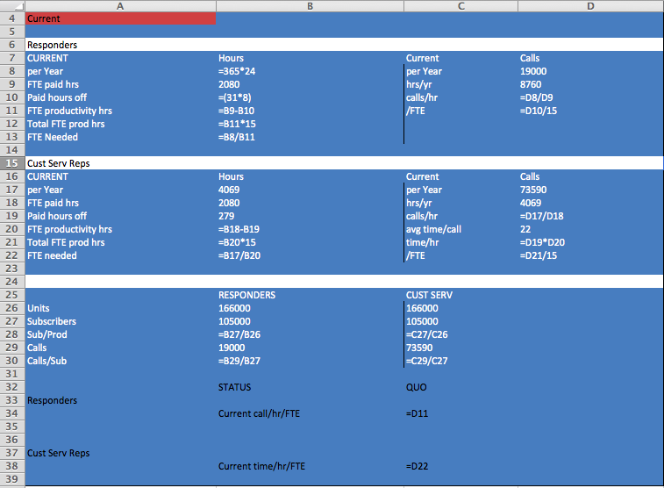

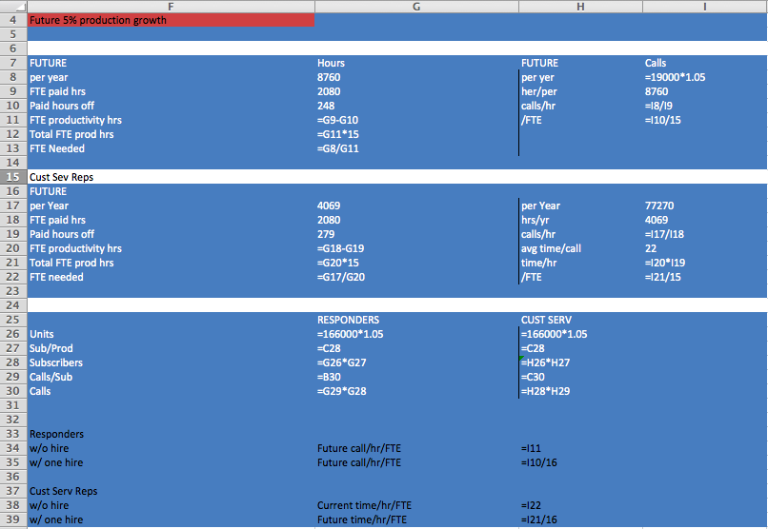

**Z2:**

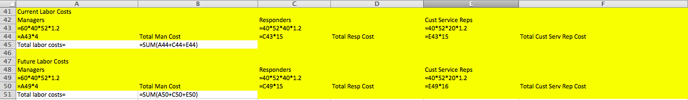

**Z3:**

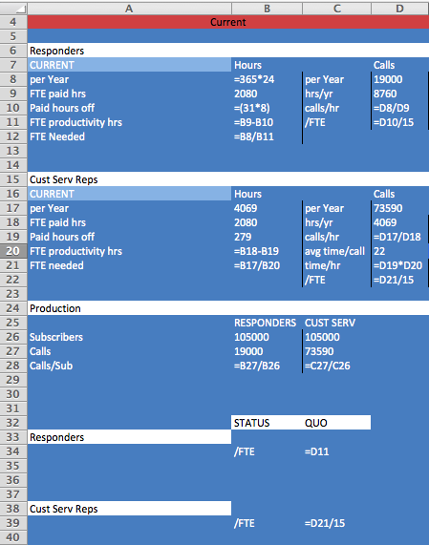

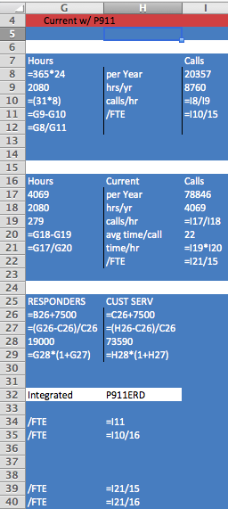

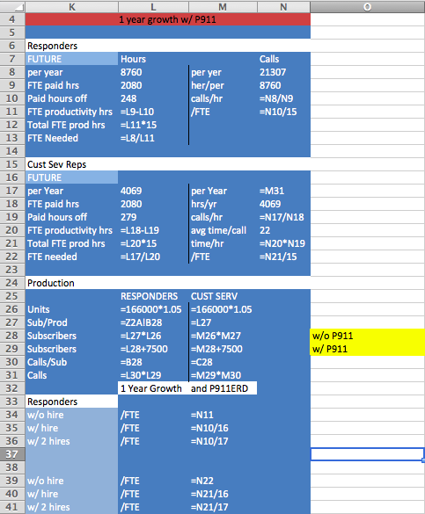

**Z4:**

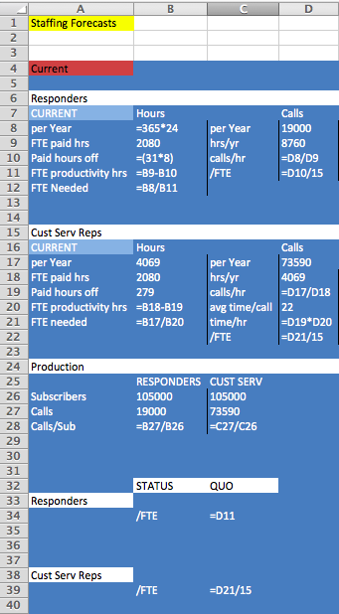

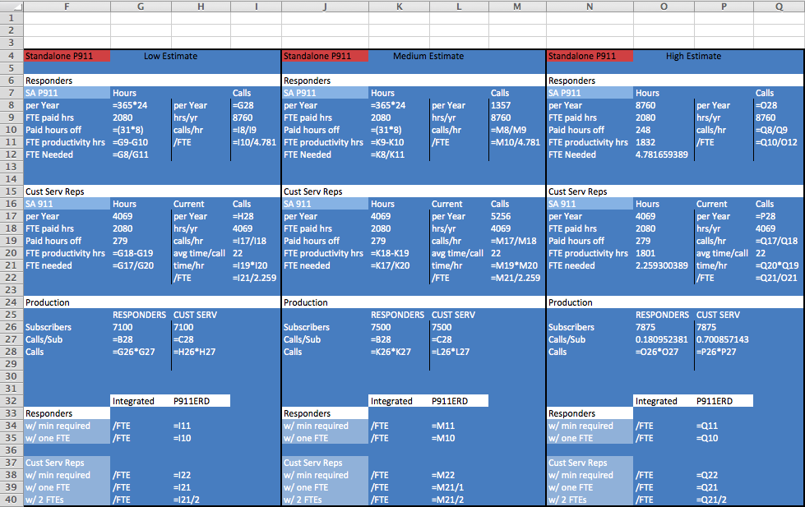

**Z7:**

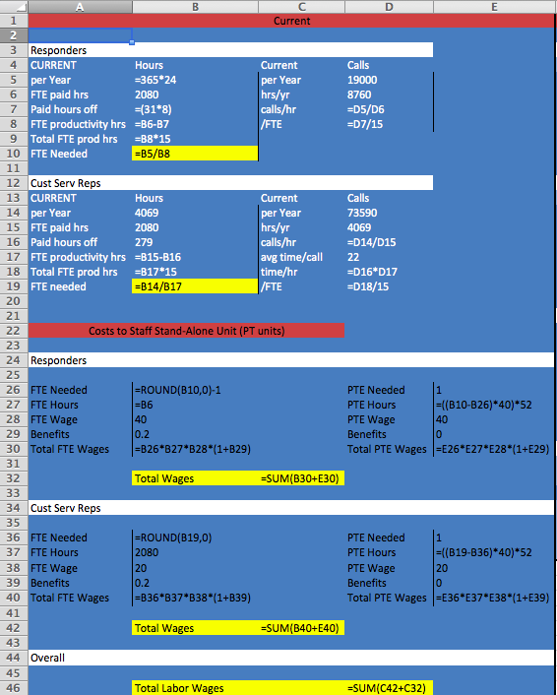

**Z8:**

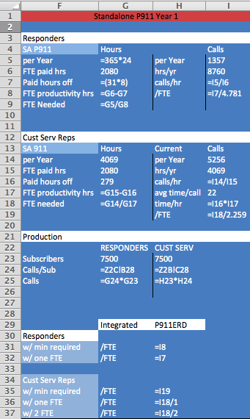

**Z9:**

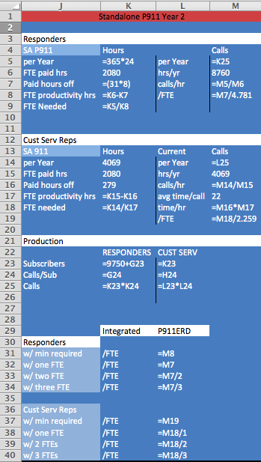

**Z10:**

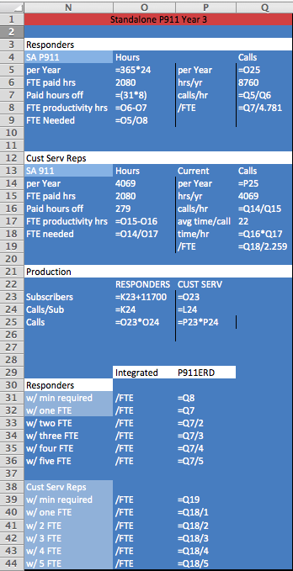

Works Cited

"Fortune 500 Mission Statements." *Fortune 500 Mission Statements*. Web. 27 July 2014.

"Human Resource Managers." *Occupational Outlook Handbook*. Bureau of Labor Statistics, 8 Jan. 2014. Web. 28 July 2014.

*Leadership*. USA: McGraw Hill Education, 2014. Print.

"Nursing Continuing Education (CE) Common Questions." *Continuing Education for Nurses*. Web. 29 July 2014.

"Nursing." *Best Programs*. US World and News, 2014. Web. 29 July 2014.

Quintela, Carlos E. "GM Vision Statement." Web.

"Registered Nurses." *Occupational Outlook Handbook*. Bureau of Labor Statistics, 8 Jan. 2014. Web. 28 July 2014.

"Texas Board of Nursing State CE Requirements." *Nursing Continuing Education*. Web. 28 July 2014.

# Marketing

## Evaluating PERSCON vs. Competition

With little differentiation among the PERS products, three firms dominate the industry. Claiming 51% of the U.S. market, NAP Corp has had a steady hold on the industry; however, it has seen a decline in its market share in the past few years. Second is AMCON with 25% of the U.S. market, which has been steadily increasing since 2009. LERT is the last dominant firm in the industry with 18% of the U.S. market, yet steadily growing in the past 5 years. PERSCON, as a small, yet rising competitive firm in the industry has maintained a steady market share around 5%. All of the above information can be found in exhibit M1.

Exhibit M2 shows the relative market share for all PERS firms. Because NAP is the strongest competitor within the industry, we compared PERSCON’s sales to NAP in order to see their relative market share. Since 2009, PERSCON had a relative market share of 7.27%, 9.26%, 9.62%, 12.24%, and 9.80% respectively. Although PERSCON’s absolute market share has been steady since 2009, our relative market share climbed steadily; with a spike during 2012 due to the drop in market share by NAP Corp in 2012.

PERSCON’s slight increase in relative market share since 2009 suggests that they are becoming a stronger competitor within this PERS market. Still, the relative market share of both LERT and AMCON has grown at a much greater pace. Acquisitions and buyouts of several smaller companies resulted in bigger market shares for the second and third strongest competitors. Exhibit M2’s “other” column depicts the effect of these acquisitions; as LERT and AMCON buyout smaller companies, the “other” column quickly approaches zero.

Although PERSCON has not acquired smaller firms, our competitive situation for expanded range devices remains optimistic. As the industry growth slowed during the economic recession of 2008, the addition of the ERD to our product line allowed us to stay competitive. We were not able to close the gap in terms of market share to any of the dominant firms, yet were able to maintain our significant share and not dwindle or be bought out. As stated in the case, PERSCON’s high stock-price to earnings ratio kept the investors satisfied with our growth and were not wooed towards other firms.

In reference to exhibit M3, we assume the ERD represents a star, showing high market growth with a high market share. The ERD will continue to produce high profits for the firm as it has the competitive advantage of the GPS system, an ability industry leader NAP does not possess. Additionally, PERSCON’s ease of use and superior quality over its competitors will allow its profits to catch up with the industry leaders quickly. While the ERD produces high profits for PERSCON, its growth will eventually slow and turn into a cash cow, which will produce a good, constant cash flow for developing other products. As the current ERD products’ market growth slows down, turning them into cash cows, the P911 ERD will enter the market as a question mark. We believe after the launch of the P911 ERD, the new product will take over as the firm’s star with funding from the current ERD products. The continued success of the innovative ERD products will allow PERSCON to maintain our strong market share, and leave the firm competitive in the PERS market.

## Segmentation

Most consumers interact with branded products because of their benefits. For PERSCON, people value the service, reliability, ease of use, and most of all safety. Though, these benefits do not help to segment the market in which PERSCON is operating. Four factors used to segment and target are:

* Demographics
* Psychographics
* Geographic location
* Use behavior

PERSCON’s original products target individuals ages 65-85 regardless of gender with health issues who are worried about getting help if no one was immediately available. Geographic location was not a focus because the product was marketed to the entire United States. Additionally, use behavior was not particularly relevant because the firm cannot forecast the frequency of use of its products among senior citizens. Our products also maintain a typical product lifespan so purchase frequency becomes irrelevant as well.

Vertically stretching the product does not change the geographic location, but adding the P911 ERD builds upon the traditional usage of PERS and even more significantly in its target market. Our given information states that the market for the P911 ERD are women from the ages of 18-35, those in assisted living homes, and outdoorspeople; whom are all sophisticated about safety. “Use behavior” purchase frequency may not change; however, usage level will be based on how cautious/careful the user lives. Therefore, segmenting based on demographics and psychographics is most appropriate for the P911 ERD. Targeting a good segment has five components:

* The segment is measurable in size and purchasing power
* The segment can be reached/accessed
* The segment is substantial in size
* The segment is differentiable
* Programs can be designed for each segment

Using these five components with the segmentation factors, we recommend women ages 18-35 as the top priority segment for P911 ERD. They are the top segment because of their interest in security not only for themselves, but also for their families. Women in this age range are likely to be college students, independent adults, or new parents with young children. Mothers often fear for their children regarding their location, safety, surroundings, etc. The P911 ERD will add value to mothers by giving them the comfort and confidence in the safety of their children. Secondly, the P911 ERD will provide security and safety for women who are still in college or recently graduated. Many of these women are often alone during nights and weekends in their cities or college towns. By using the P911 ERD, safety is just a click away and the danger is eliminated. This segment is also first priority because, although these women may not yet have kids to buy the product for, they may have parents who demonstrate a need for a PERS device. Therefore they would be influenced to buy for their older family members as well.

The second priority segment we recommend targeting are those people who live in assisted living centers. 10,000 baby boomers will be becoming senior citizens every day through the year 2020, many of whom will refuse to move into a nursing home much like founder Art Smith’s parents. With the independency of assisted living facilities, the P911 ERD would prove attractive in the market where senior citizens do not always want someone watching over them. Additionally, the P911 ERD would be sold in bulk to the assisted living centers rather than the people in them, which would create large profit margins for PERSCON with only one sale.

The final priority segment we recommend are those who enjoy the outdoors and adventure (hikers, campers, bikers, etc.). Because these people crave risk and danger and are often not near health care facilities, the P911 ERD gives them the comfort of a response system should they encounter danger; however, they are the last segment we recommend targeting because we assume they may be resistant to such security due to their desire for risk. We believe that this priority of segments is essential to improving PERSCON’s brand equity, as a younger overall customer base will be in need of our devices for a longer period of their lifetime.

In order to target these segments effectively, PERSCON will have to use a differentiated targeting strategy for their P911 ERD unit, as seen in exhibit M4.As opposed to the previous concentrated strategy exhibited where the product targeted only senior citizens, the new segments will have different reasons to use the product, and will not respond to the same marketing strategy. Therefore, PERSCON must use one promotional mix to appeal to women 18-35, another mix involving personal selling for those in assisted living facilities, and yet another promotional mix for the those people who aspire for adventure and the outdoors. Promotional strategies are discussed further in this report.

## Positioning

Positioning is directly related to differentiation from the consumer’s viewpoint. Developing a position in the market shows what the brand stands for and its competitive advantage. Multiple firms’ position in an industry can be demonstrated by a position map, as shown in exhibit M5.A positioning map plots brands on a map in relation to two attributes that run consistently through the industry. In the PERS industry, these two attributes are price and quality/reliability, in which PERSCON would hope to represent high quality and low price. To be more specific on what a firm stands for, a positioning statement is developed.

A positioning statement answers three basic questions: who are the customers, what is the set of needs this product fulfills, and why is the product the best option to satisfy those needs? The positioning statement for PERSCON’s vertical stretch with the P911 ERD is: “To those sophisticated about their safety who seek protection at the press of a button, PERSCON is the brand of quick and reliable assistance that follows you globally so you may lead your own lifestyle.” This statement addresses:

* The target: “To those sophisticated about their safety”
* Their need: “who seek protection at the press of a button”
* The concept: “quick and reliable assistance”
* The point of difference: “follows you globally so you may lead your own lifestyle”

This positioning statement applies to our company because of our advanced GPS technology. PERSCON is unique to the competition because we can locate our customers anywhere using a satellite or Bluetooth signal and reach them instantly and reliably.

Customers buy products from firms based on their perceived value of the products. The customer’s perceived value is their evaluation of the difference between all the benefits and all the costs of a market offering, relative to competitors’ offers. Therefore, customers do not judge or buy products based on objective measures, rather on value created by the comparison of costs and benefits of the product. Customers’ perceived benefits of PERSCON are extensive and reliable customer service, product support, and assured safety and security. What causes consumers to buy their products is how the perceived benefits stack up against the costs of using the products. Our current ERD products being manufactured maintain explicit costs to the consumer with a $50 activation fee with each pendant registered, along with a $49.95 monthly lease payment. Additionally, the battery in the transmitter must be replaced annually with a charge of $10.00, and any fees associated with the PERS device are not routinely covered by insurance. Benefits of our current ERD products are their simplicity and ease of use, affordability, reliability, and superior quality versus competitors. Furthermore, it has the ability to reach and locate anyone within 750-1000 feet from a cellular station, providing help for medical emergencies at the push of a button or voice activation. Though, the greatest benefit of our current ERD products is the zero defect quality assurance: if a customer has a defective device, it is replaced overnight by PERSCON with the customer returning the faulty device back to PERSCON. This policy is unique to PERSCON and is what sets us apart even further from our competition.

With regards to the P911 ERD, most of the costs decrease while the benefits amplify. Because the P911 ERD has a higher standard for what they consider an emergency in order to eliminate the problems with “false alarms,” consumers also believe that there is a higher standard of quality and service. Users still must wear the pendant/bracelet but pay lower activation, lease, and battery replacement fees. Yet, because the P911 ERD will be offered to an entirely new market, the perception of the products use (a senior citizen saying “help, I’ve fallen and I can’t get up”) may be carried over and viewed as a social cost to wearing the device. Increased benefits of the P911 ERD are the increased range and usage of the product. These devices can be reached and located anywhere on the globe using satellite or Wi-Fi connection. The product will be used for additional personal safety situations as well as medical emergencies. The P911 ERD also increases affordability and reliability.

## Evaluation Distribution Channels

PERSCON uses multiple promotion approaches to reach its customer base, while still maintaining integrated marketing communication (IMC). IMC means that although there are different methods being used to market and communicate a product or brand, each method portrays the same message, therefore different segments of customers have receive the same message about the product (safety and protection). RESPONSIVE MARKETING, an outsourced call center costs us $129.39 per customer that they acquire. RESPONSIVE is costly because we rely on them to respond, handle inquires, and actually make the sale; all of which would otherwise be routinely done by our company. The second marketing approach places order forms in magazine ads that are filled out and sent with credit card information to a PERSCON handling center. This method costs us $48.81 per customer acquired. RESULTS, LLC. is another outbound telemarketing call center. PERSCON pays RESULTS $5 per new customers they provide. The remainder of customer acquisitions came from late-night TV ads, which costs PERSCON $25.64 per thousand viewers. All calculations can be seen in exhibit M6.

When evaluating the current distribution approaches, we recognize not only the cost to acquire the new customers through each marketing channel, but also the cost to simply reach customers. The best results PERSCON has gotten are through the magazine ads with order forms. By simply placing an order form in a magazine, there is no additional cost to pay for an outsourced telemarketer or additional marketing efforts. The process is simple and direct, in which the consumers order and receive their products straight through a PERSCON handling center. This method also has the lowest CPM of $18.07. The second best distribution method is using RESULTS LLC. Since RESULTS is a telemarketing center, it makes an extra effort to acquire new customers for PERSCON. Although RESULTS is paid $120,000 annually, they were able to bring in 24,000 new customers during a year, beating out all of the other distribution methods combined. RESULTS is not as expensive as other telemarketers because they make a set dollar amount per sale, no matter how large the sale may be. Nonetheless the process is outsourced, so PERSCON runs this risk of lack of brand control over the marketing effort, and therefore risks its relationship with its customers. Similarly, RESPONSIVE MARKETING is an outsourced call center. RESPONSIVE provides the same risk regarding customer relationships, as this is often times customers’ first introduction to PERSCON and their first time purchasing one of our devices. Since RESPONSIVE is responsible for all of the processes that would routinely be done by PERSCON, they provide the highest cost for the lowest number of newly acquired customers. RESPONSIVE’s costs are also high because they charge PERSCON for each incoming call as well as a commission. Therefore, even if RESPONSIVE failed to make any sale, they would still pose a cost. When they do make a sale, they are paid a percentage of revenue, which increases costs exponentially. Additionally, RESPONSIVE has the highest CPM of $27.50. PERSCON’s late night TV ads cost less; however, we cannot determine how much revenue and how many new customers they actually generate. Due to this uncertainty, we cannot sufficiently evaluate the effectiveness of the late night TV ads.

As a result of the high yield-to-cost ratio and the changing target market, we strongly recommend the continuance of order forms in magazines for distribution of the P911 ERD. With an increase in customer base and younger target segments, more magazines can be used to place orders, where impressions and, ultimately, orders will increase. We also believe that if PERSCON would like to continue using an outsourced telemarketer, we should remain with RESULTS LLC. as they are far more efficient and bring in a larger number of customers than RESPONSIVE MARKETING.

We also believe that using a web site to sell P911 ERD is a necessary distribution method. Not only does selling online lower costs and delivery times, but also younger customers prefer to shop online as it is cheaper and more efficient. By devoting a web page to the product, PERSCON can provide sufficient information and spread awareness of the P911 ERD. Customers will be able to become fully educated on how to use and depend on the product, something that PERSCON must emphasize to continue to grow and remain competitive within the industry. Web sites are also helpful in getting information on consumers and getting consumers to interact with the brand, as they may be directed towards other marketing efforts or the firm’s social media sites. The use of a web site may also eliminate the need for one of the call centers, as they provide the highest cost to acquire new customers. Although the need for call centers will never be fully eliminated, dropping RESPONSIVE MARKETING would be a cost advantage for PERSCON since they cost the most to acquire new customers.

While PERSCON currently has the Emergency Response Center, the company still needs a CRM system. Proper customer relationship management involves making the brand a meaningful part of consumers’ lives, a focus which in the PERS industry, is as essential as any other. With the Emergency Response Center, PERSCON maintains a focus on creating an experience for customers in which our products make a strong impact on their lives. We pride ourselves on providing high quality and superior product support. In order to enhance these two prestigious outlooks for our firm, PERSCON should join online social networks such as Facebook and Twitter. These social media networks provide platforms where brands can house market offerings and messages that involve customers; essentially promoting brand-consumer interaction. We encourage consumers to talk about their experiences with the product, which generates consumer managed relationships. Responders, who otherwise spend their downtime uselessly, can be used to maintain the social media sites and interact with the consumers; since they already focus on customer experience. Even more vital, proper CRM allows the company to integrate with the consumer culture more easily. By interacting with the conversations of users rather than interrupting them, firms generate increased interest and awareness of their brand. A multitude of companies already use twitter to:

* Start conversations with Twitter’s over 200 million users
* Address customer service issues
* Research customer reactions
* Drive traffic to relevant information and articles
* Respond quickly to individual problems or questions

Facebook carries the same usages with a larger reach of over one billion people. Another useful online media site is Google Analytics, which would allow PERSCON to assess the performance of our segmented targets. Understanding these targets is important to effective marketing efforts. By allowing firms to partake in all these options to further help their customers, social media builds customer relationships and sales.

A key CRM program for PERSCON involves establishing a membership system on our website where members can change their preferences with our company as they like. These preferences would give our firm inside information on how to please our customers. If PERSCON implements CRM properly, we would be able to gather customer data quickly, identify the most valuable customers, and increase the loyalty of those customers. This also leads to identifying those customers who are not profitable to the firm and letting go of those customers. In reference to exhibit M7,firms should look to maximize the value of true friends who are long-term, highly profitable customers and do away with barnacles who are long-term, unprofitable customers. Ultimately, if a firm is able to “fire” unprofitable customers such as barnacles, and possibly turn strangers and butterflies into true believers, they can place a larger and more magnified focus on the most profitable and valuable customers. PERSCON would be able to eliminate customers who do not use our products properly and help serve our most valuable customers better; however, PERSCON must be careful when rolling out our CRM project. We must keep in mind that successful CRM requires a proper customer strategy, an organizational change to match the system, the right amount of technology, and attracting customers rather than intruding. A proper CRM system is essential for us to establish a niche in this new market. We must gain an understanding of our new consumer segments and create an atmosphere of brand interaction and loyalty to truly capture the market.

## Promotion Decisions

Promotion means communicating the product to the consumers to create a position for the given product in the consumers’ mind. The four objectives of promotion include informing, reminding, persuading, and building relationships with customers. Firms use multiple methods of promotion to communicate their brand to consumers, all of which provide different advantages and disadvantages. A promotion mix displays four effective promotion opportunities that firms may use to create awareness about their product and build sales. The promotion mix consists of:

* Advertising
* Public Relations (publicity)
* Sales Promotion
* Personal Selling

PERSCON has already employed the advertising promotion method, as it currently runs television ads, as well as placing ads in magazines. Because advertising is considered the paid use of media, none of these efforts come free. As seen above in “evaluating distribution channels,” placing ads in magazines costs much more than running a television ad, yet acquires and reaches customers at a much more apparent rate. Advertising is an effective tool for this business model, and we recommend continuous use of this promotion option. Advertising through magazines and television will help reach a large percentage of the new target segments efficiently and effectively. We also recommend beginning to advertise online and on social media sites like Facebook. Advertising online provides another advantage to reaching this new customer base. Young consumers are online, specifically Facebook, almost every day and would allow for the mass sharing of the advertisement.

Publicity is another promotional method that may prove highly effective in attracting and acquiring new customers. Because PERSCON is in the business of saving lives, it would not be atypical to see a press release about someone using their product to save their life. This may be initiated by news stations that see a huge advantage of the product, or possibly initiated by PERSCON to boost and grow sales quickly. Another form of publicity is testimonials by actual customers who have used the product. Testimonials provide credibility and real usage of the product; a convincing method to persuade consumers to believe in the need of the product.

A sales promotion would not be effective in promoting the P911 ERD. When considering short-term coupons, rebates, price discounts and displays, PERSCON may offer products at a discounted price or even pose a buy one get one free option. Nonetheless, these methods may decrease credibility of the product and make it come off as a cheap commodity item, which is not what PERSCON is providing. With the P911 ERD becoming more affordable as well as reliable, PERSCON must keep the perception of superior quality by not offering the device at lower prices than normally offered.

Personal selling is something which PERSCON already employs by using RESULTS LLC. and RESPONSIVE MARKETING. Yet another use of personal selling can be used to reach one of our new target segments. In order to reach out to assisted living centers, representatives from PERSCON can visit the centers and deliver a promotion opportunity to leaders of the homes or groups of people within the homes. In doing so, PERSCON can reach a large number of people at one time and have the possibility of selling in bulk with continual orders of the product. Getting their foot in the door of these facilities can establish a long-lasting relationship in which the community continually buys products for the residents in the living in the centers, due to the short lifespan of our products. Because the assisted living centers do not provide medical care on staff, we see a need for the product in these facilities and strongly recommend exploring this option.

As a part of the message strategy, there are four types of advertising campaigns that PERSCON may use to build the brand and drive sales:

* A word hook
* A character hook
* A repeatable theme
* A consistent brand layout

A typical promotion for the P911 ERD would portray a responder answering a medical or safety emergency call as the repeatable theme. A character hook can be created using the same responder to answer different emergency calls. The responder should represent someone who is caring, compassionate and reliable, and would recite a word hook regarding safety and protection. The different consumer segments and emergency situations would make it difficult to portray a consistent brand layout; however, we would aim for a consistent theme of a distressed patron in dire need of assurance.

Exhibit M8shows an example of a web page to promote P911 ERD. Using this framework, customers can easily learn information about the company and product through pictures and descriptions. Customers can explore the web page to see the important aspects and benefits of using the P911 ERD. A website is helpful in clearly educating consumers on the need and reliability of PERS devices, an aspect of this industry that is essential to success. Additionally, the web page offers weekly testimonials given by customers to help promote the product or any possible sales promotions. The web page will also be an effective way of connecting customers to PERSCON’s social media networks, with links featuring the companies Twitter feed and Facebook page. These links as well as the testimonials provide viewers with a perception of our ideal target market. At the bottom of the page reads the positioning statement for PERSCON, as a constant reminder of our message benefits and unique selling proposition.

## Pricing P911 ERD

Pricing the P911 ERD poses a difficult task, as the value of this product varies based on the targeted consumer segment. Those who are older and more mature see a greater need for this product and will therefore be willing to pay more for the product; however, those who are younger do not see this product as essential and therefore are more resistant to paying a high price for the product.

In order to price the new product, PERSCON must use one of two strategies: price skimming or price penetration. Price skimming involves charging a high, premium price for a product and benefits that customers want at any cost, progressively lowering that price over time to capture the late majority and laggards. Due to the nature of the product we do not believe that this pricing strategy would be very effective, as people would lose confidence and assurance if the price continually dropped over time. Therefore, we recommend using a penetration pricing strategy, where we introduce the P911 ERD at a low price to encourage demand and sales at the early stages. This strategy discourages competitors from entering into the market. Since the average price of a monthly lease for a PERS device is $49.00, we recommend undercutting this price to $40.00 a month. The decrease in price will spark an interest in new consumers’ minds as well as those consumers currently paying a higher monthly price. We also recommend lowering the activation fee to $25.00, a much more reasonable price for consumers in each segment. Because the monitoring service with a monthly fee is the primary profit generator, the entry price can drop well below previous prices, which will highly entice customers to join the service. The activation fee and monthly lease serve as captive product pricing, as you cannot have one without the other. We gain profit from repeated purchases (lease payments), which allows for a low entry (activation) price.

Another pricing strategy we recommend is price bundling, which we can implement one of two ways. In selling to a group of people, for example an assisted living center, a number of different devices may be purchased at one time. In order to encourage this, PERSCON may want to sell a bundle of devices together with one flat rate activation cost for bulk purchases so that the entry price is even smaller and more appealing to the customers. This way, multiple leases may be set up at once and profits can begin to stack up quickly. Another form of price bundling comes into place when appealing to parents or families. Activating additional devices allows for families to receive a discounted activation fee for adding additional devices to their account. By doing so, parents will be encouraged to buy more devices for each of their family members, including their children and even their parents who may be entering their senior years. PERSCON will not suffer too greatly from the low activation cost because they will always maintain a constant lease price, which is their primary profit generator. The chart below shows price bundling discounts.

|  |  |  |
| --- | --- | --- |
| **Customer** | **Activation Fee** | **Monthly Lease Rate** |
| Individuals | $25 | $40.00 |
| Families (2-10) | $20 | $40.00 |
| Bulk Order (25-50) | $15 | $40.00 |
| Bulk Order (50+) | $10 | $40.00 |

The value proposition for P911 ERD is more for less, indicating that the product offers more benefits than the typical PERS product for a lesser price than previously offered or than competitors. Building value for customers contains four ideas, proposed by Theodore Levitt:

* There are no commodities
* Products are problem-solving tools
* There is a bias toward the measurable
* Make the intangible more tangible

The P911 ERD addresses all of these issues. In a hard to differentiate industry, we separate our products with longer product life-span, higher quality, and GPS capabilities. The P911 ERD is also addressed as a problem-solving tool because it assures safety and protection, a problem that all new target segments are concerned with. PERSCON has made an attempt to measure an increase in aspects like customer satisfaction, necessity, and reliability. Lastly, PERSCON is making the intangible (reputation and brand equity) more tangible. As seen in our positioning statement, we are making an attempt to market ourselves as the brand of safety and protection, while offering superior quality and reliability. Added to the tangible benefits of an unlimited range and increase type of usage, the P911 ERD offers more benefits to its customers for a lower price than the average $49.00 monthly lease.

## Global Marketing Strategy

When looking to expand into Asia, PERSCON must be mindful of the cultural shift from the American market to the Asian market. In many Asian markets, business is done at a much slower pace, based on long-standing relationships and trust. Therefore, it would take quite some time for PERSCON to establish itself in an Asian market with a solid consumer base. Furthermore, government is very involved in business, whereas in the current business situation, government has little influence over the actions of PERSCON and its customers. The freedom that PERSCON has experienced in the U.S. market would be challenged drastically in the Asian market. Another concern for PERSCON may be the infrastructure in most Asian countries, which is not as developed as America. Getting emergency response vehicles to those using the device would take longer and be much more difficult to complete efficiently. Additionally, the marketing team may have a concern of its own with how to communicate the need for PERSCON’s products in the Asian market due to their family and status-oriented cultures. Most Asian cultures believe in younger members of the family as caretakers to older members; therefore, a major obstacle PERSCON would have to overcome is how to promote a need for our products. We do not believe the firm is quite ready for a market-development strategy to go overseas, as we must first see how successful we can be in targeting new markets in the United States. Diversification is the most risky and difficult of the four expansion strategies, seen in exhibit M9.

The market entry strategy that seems the safest given the current state of the company is a joint venture, in which there is ownership in both the home country of the United States and the expansion country in Asia. This market entry strategy protects the company’s capital investments as well as its brand reputation. By allowing management to work in both countries with constant communication, the risk of failure is minimized. Referring to exhibit M10, the most effective way to enter the international market in Asia would be to use promotion adaption. By promoting the need for the same life-saving products using a different promotion method, PERSCON may be able to effectively communicate the need for the product; however, if we were to keep the same promotion strategy that is used in the United States, the firm would likely fail.

Conducting business in Thailand is much like business in other Asian markets. The culture strongly respects status and long-lasting relationships and has a close relationship between the government and business. Yet, Thailand generally encourages foreign investment, especially related to new technology. This provides a positive outlook if William is looking to establish foreign investment in Thailand; however, he should be mindful of corruption possibilities and develop policies for dealing with corruption before establishing business in Thailand. Managers should also be mindful of addressing conflict, as it is often dealt with behind closed doors, if at all. If PERSCON does decide to pursue business in Thailand, we should be mindful to take time to first develop relationships with the Thai, and work through a trusted partner so we are not going through their society, business, and government blindly.

## Marketing Appendix

**Exhibit M1: Market Share of PERS Industry**

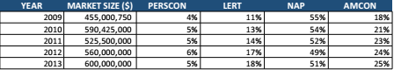

**Exhibit M2: Relative Market Share of PERS Industry**

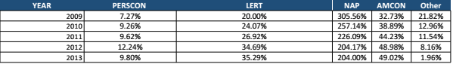

**Exhibit M3: Boston Consulting Group Market Share/Market Growth Matrix**

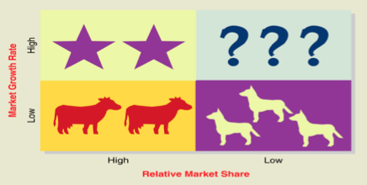

**Exhibit M4: Differentiated Targeting Strategy**

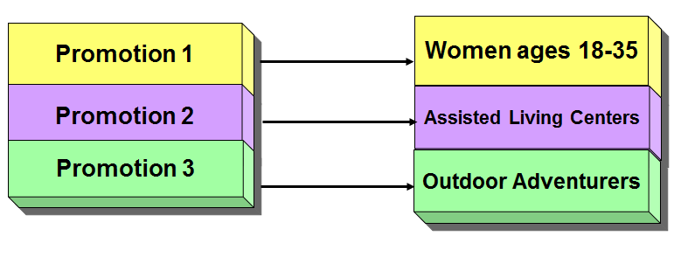

**Exhibit M5: Positioning Map**

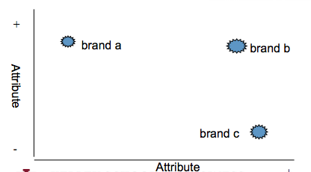

Quality

+

Price

AMCON

NAP

PERSCON

**Exhibit M6: Calculation of Acquisition Costs and CPM for Current Distribution Methods**

RESPONSIVE MARKETING

Magazine Order Forms

RESULTS LLC.

Late Night TV Ads

**Exhibit M7: Customer Relationship Groups**

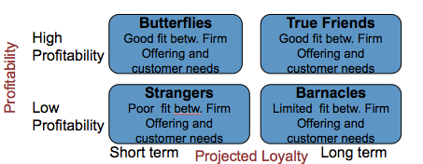

**Exhibit M8: PERSCON P911 ERD Web Page**

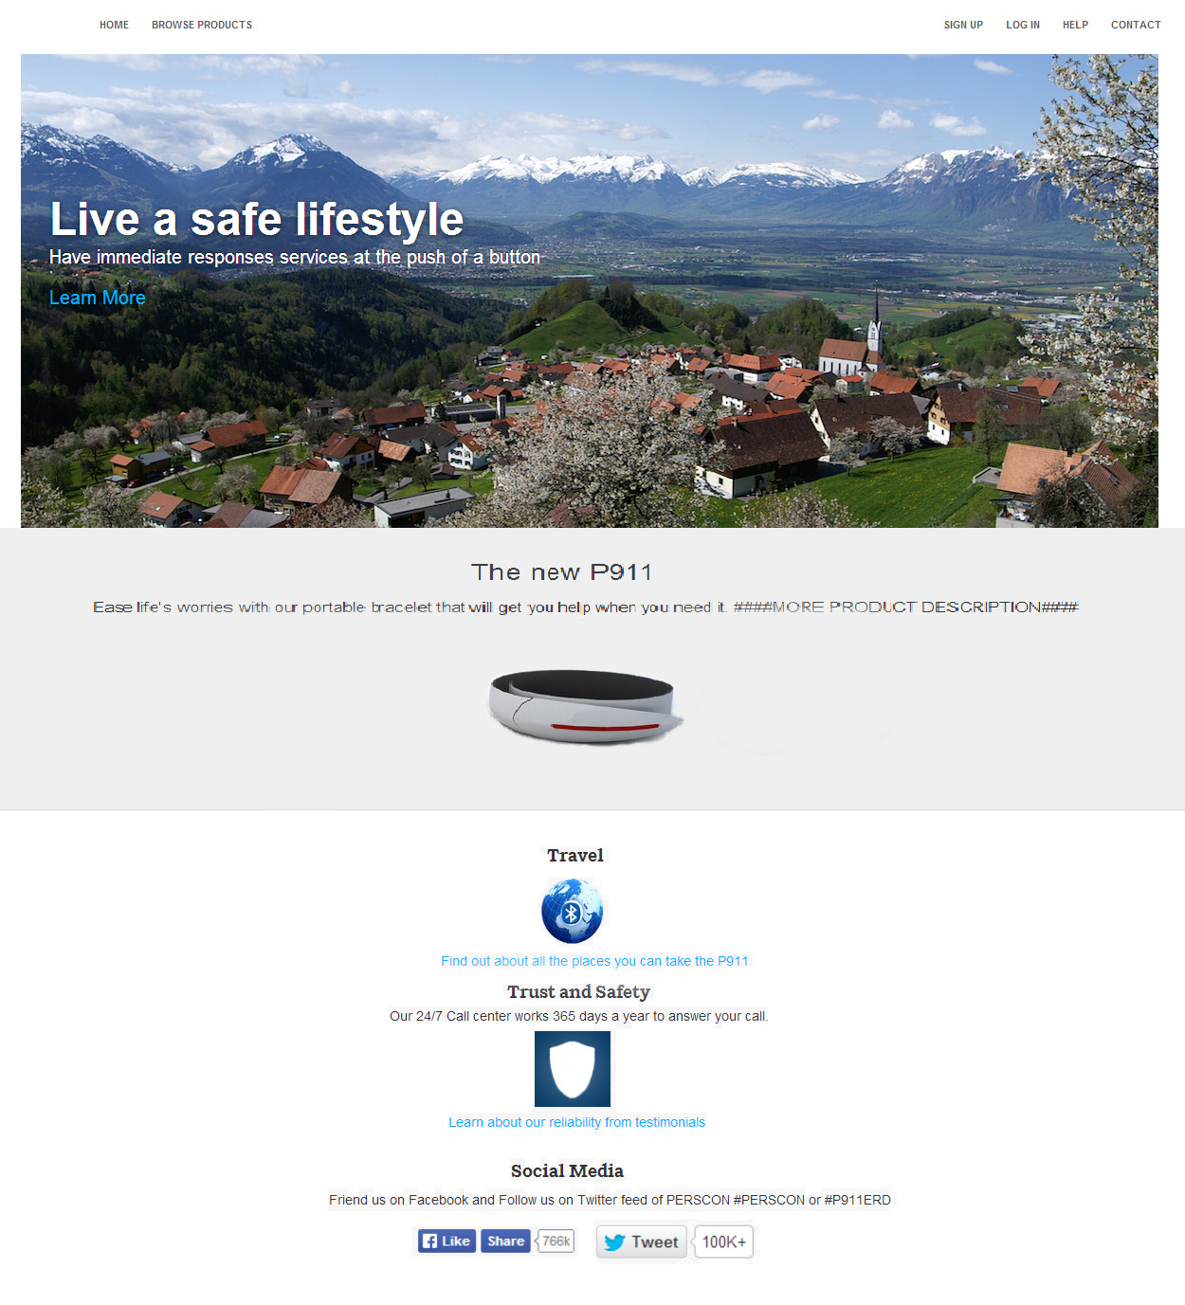

The website includes:

* Product and benefits description and pictures
* Education on use of product
* Testimonials
* Positioning statement
* Log-in and sign-up for CRM

“To those sophisticated about their safety who seek protection at the press of a button, PERSCON is the brand of quick and reliable assistance that follows you globally so you may lead your own lifestyle.”

**Exhibit M9: Product/Market Expansion Grid**

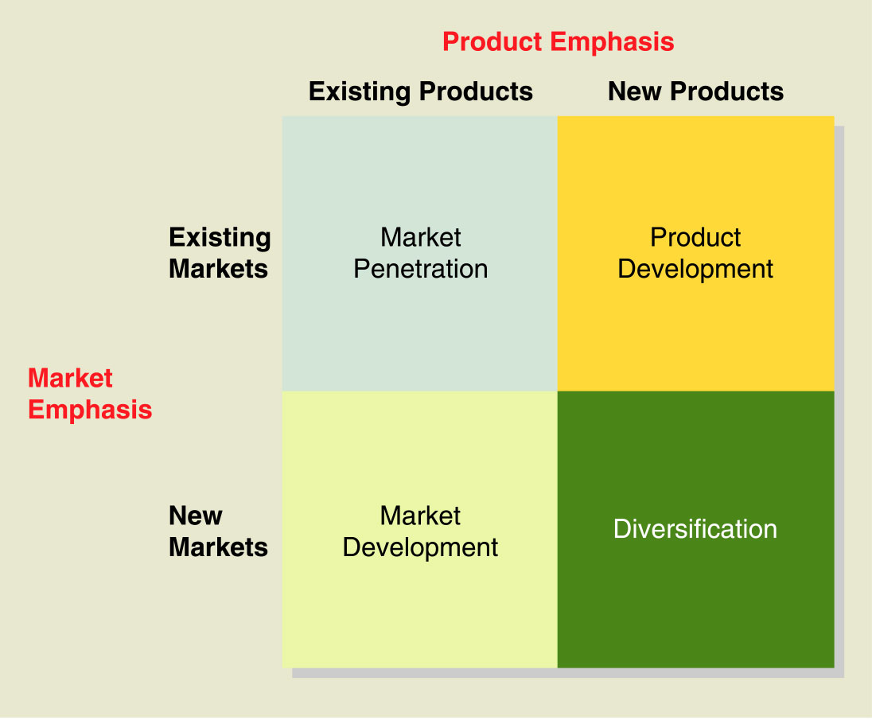

**Exhibit M10: International Product and Promotional Strategies**

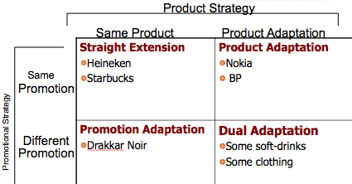

# Operations

## Capacity Management

In our analysis, we assumed that a combination of machines and workers make up the machine paced system. We formulated exhibit P1 to take all relevant costs into account. We also eliminated storage costs by enacting a chase plan; we produce equal to demand. Because worker cells are flexible and can slow the pace of their work, we always rounded up to a whole number of worker cells. We chose to buy two machines at year one and stick with two machines for the next five years because it is the cheapest long-term machine paced option. Buying a machine in year one and another in year two yields lower costs for year one but much high costs for year two and the overall forecast. With uncertainty in mind, we decided it is still best to purchase two machines in year one.

Exhibit P1 shows that full worker paced lines are $574,990 cheaper after five years of production; however, this is subject to uncertainty of future demand. Increases or decreases in certain costs, such as materials and shipping will not affect the comparative analysis because they derive from demand, which is equal in both systems. Installation costs are also irrelevant in the final decision because, barring over a 400% increase in worker paced installation costs, even free installation costs for machinery still favors a worker paced system overall.

Changes in per unit labor, maintenance cost, and equipment cost (either machine or worker) could change the decision. For example, if per unit labor cost for machines dropped to $63, using a machine paced systems would become more cost efficient. Conversely, if workers demanded higher wages (possibly becoming unionized) and per unit labor cost for workers changed to $98, using a machine paced system again would become more efficient. These decision-changing points are found assuming all other costs remain the same. Infinite combinations of increases or decreases in these three costs could change the analysis.

Based solely on cost efficiency, the worker-paced unit is cheaper; however, there are many other considerations such as variance caused by human error, workers’ inconsistent production rate, and training costs. Machines are also subject to shutdowns or unexpected failures. Depending on depreciation and salvage value, the increased assets from the machinery might be favorable from an accounting standpoint. All things considered, we recommend a worker-paced system because of the lower costs in year one and overall added flexibility. Exhibits P2 and P3 support that after one year, considering high, medium, and low demand, a worker-paced system is the most cost efficient decision.

We calculated the high and low demands, as seen in exhibit P2, using the same method we use when calculating standard deviation of lead time. With increased uncertainty each year, the standard deviation of demand increased as well. For example, for year two, instead of assuming standard deviation of demand as 100, we squared 100, multiplied by two, then took the square root. We took the final calculation and multiplied by 3 to account for 3 standard deviations.

## Order Policy

Order policy involves how much to order and when to order. If we operate using the economic order quantity, we find our purchase quantity by setting total annual holding cost equal to total annual setup cost. We then calculate reorder point based on our desired service level, average demand, and standard deviation of average demand.

Choosing a supplier based on an economic standpoint depends the total annual cost of each supplier; however, lead time contributes to the difference in cost. Supplier ABC has a lead time of 15 days while supplier P2 has a lead time of 10 days. The difference in lead times between the two companies changes the holding cost of PERSCON; a higher lead time increases the cost of holding safety stock. Because of the increase in lead time, the reorder point will increase as will the uncertainty of demand during lead time, causing a higher holding cost. Exhibits P4, P5, and P6 show that supplier ABC has a higher reorder point and holding costs than supplier P2. Supplier ABC has a safety stock of 3.18 units while supplier P2 has a safety stock of 2.59 units. To calculate the difference of the holding cost between these two companies we simply multiplied the safety stock of each supplier by the holding cost per unit which resulted in $10.20 difference in the holding cost. Additionally, there are soft costs of having a higher probability of a stock out during a longer lead time. This leads to loss in revenue and brand reputation.

Using a confidence level of 95% and the average demand of 7,500 units with a standard deviation of 100, we calculated the highest demand to be 7,664. This demand minimizes our underproduction risk and backorders to 5%.

To further understand the lead cost, our team created exhibit P4, which has lead times ranging from 1-20 and the lead time costs of both companies. We bold the actual lead time and lead time cost for both companies, and we can see that the lead time costs keep increasing as the lead time goes up. This is due to the dependency of safety stock to the lead time.

The differentiating factor that PERSCON needs to consider is the total annual cost. The total annual costs from exhibits P5 and P6 are the sums of total annual holding costs, total annual setup costs, and total annual purchasing costs. We can see that supplier P2 has a lower cost across all cost categories. The total annual purchasing cost indicates that supplier P2 has a lower cost per unit. The difference of the cost between these suppliers is pretty significant. Supplier ABC has a total annual cost of $585,014.60 while supplier P2 only has a total annual cost of $540,649.17. We recommend PERSCON to choose supplier P2 in terms of economic perspective because we will save approximately $44,365.43, $10.20 of which is contributed to lead time.

## Project Management

Given the chart of CPM with 3 time estimates, our group calculated the expected time of each activity. These values are displayed in exhibit P7, which shows completion times as well as slack. The slack, which is demonstrated by the orange bars on the back-side of the normal duration for each project, determines the latest time that an activity can be delayed without delaying the entire project. Activities that lie on the critical path, demonstrated by the red bars, have no slack and therefore if delayed, will cause the completion of the entire project to be delayed. The critical path of activities GIKNRS indicates that the normal duration of the project is 35 weeks, or 175 days. Exhibit P8 shows the network diagram activity, displaying precedence, normal duration represented by the top nodes, and minimum duration of the activities represented by the bottom nodes. Again the critical path is seen to be 35 weeks or 175 days. Expected time was used to create exhibit P9, which shows early start, early finish, late start, late finish and slack time for each activity.

In order to successfully launch the project in time for the trade show, the project must be crashed so that it is ready for launch in 27 weeks. Exhibit P10 demonstrates the critical activities that require crashing in order to meet the 27 week deadline. The project is crashed according to the cheapest activity crash costs that lay on the critical path. Project crashing can be seen in exhibit P10, in which paths CJRS, GHKNRS, and GIKNRS all had to be crashed in order to meet the 27 week deadline. Total cost of crashing equals $6,925. The 27 week project will cost a total of $106,925.

We derive the total cost of the project from a labor cost of $100,000 for the normal duration of the project and the crash costs of $6,925. We only crashed the project to 27 weeks because there are no explicit administrative costs to save. Our objective is to have the project ready in time for the trade show while incurring the least costs. Crashing beyond 27 weeks will create unnecessary costs since we only need to be ready by the trade show deadline.

## Quality Management

Quality management assesses both the quality of the product being manufactured as well as the suppliers that manufacture the products. While supplier ABC has a better process quality, supplier P2 produces its product at a much lower defect rate and consequently has a higher product quality. In the PERS industry, it is vital to produce non-defective products, as defective products in the field may lead to the death of a customer and impending lawsuits which could be fatal to the firm. Because of our historical problems from improperly loosely seated circuit boards in the module, it is of the utmost importance to choose the supplier that is least likely to produce defective products, which we determined to be <.9 mm or >1.1 mm of thickness. Accordingly, we believe that the defect rate should ultimately determine who provides the higher quality, though the variances in the processes should also be considered. Based on the two test samples given by suppliers ABC and P2, we believe that supplier P2 provides a higher quality product.

With the help of control charts, we can see that nearly all of ABC’s processes are in control, yet produce at a high variance. What causes us to believe that ABC is inferior is their very high, 40%, defective rate. Displayed in exhibits P11, P12, and P13 are the charts for ABC’s second test sample’s x-bar, range, and p chart. Because none of the processes appear to be out of control, we can only assume that the high variance in their products is due solely to common cause. Individual changes to the process would cause the process to become out of control; therefore, we assume the high variance is due to the materials being used, and only a change to the process in its entirety could solve the issue. Due to the defect rate of their products and their possible failure once reaching the consumer, our analysis has led us to conclude that P2 has the better quality.

Supplier P2’s product defect rate is about 15%, which is less than half of the defect rate that supplier ABC produces. The quality in their products also point to the low variances in their processes. Exhibits P14, P15, and P16 display the x-bar, range, and p charts of supplier P2’s second test sample. Although the control charts indicate that their processes are out of control, nearly all of their data points remain around the center line, indicating a very low variance between products. An investigation of the processes is necessary to determining the reason for the processes being out of control. The x-bar chart appears to be out of control because one of the samples had a higher average thickness than the rest. The range chart appears to be out of control because one of the samples produced its products with a wider range of thicknesses. The chart also indicates that it may be trending upward heading into the future; pointing to a continued growth in the range of its products. An investigation in the processes would help clearly identify the reason for the single statistics out of control. A fix to the process would change supplier P2’s processes to be in control and give full confidence in the quality of this supplier. Although supplier P2’s processes require an investigation and change, their very low defect rate assures their products are of a higher quality.

PERSCON’s quest for quality is to eliminate the production of defective products because failure of a device in the field is unacceptable. This quest for quality is reassured by PERSCON’s zero defect quality assurance policy, in which we are forced to replace defective products for customers overnight at our own cost. In order to reduce the number of defective products, it is necessary for PERSCON to reduce the variance in our overall processes and production. In order to achieve our desired quality, we must strive for total quality management, which varies on the eight quality dimensions of:

* Performance
* Features
* Reliability
* Durability
* Conformance
* Serviceability
* Aesthetics
* Perceived Quality

In regards to quality we aim to improve performance, reliability, durability and serviceability by ultimately reducing the variance in the production of our ERD products. We suggest using the Six Sigma methodology to accomplish this objective.

Six Sigma involves defining, measuring, analyzing, improving, and controlling processes to reduce variability. ISO certification for ourselves as well as all of our suppliers establishes a minimum quality standard for internal processes. With regards to improving these already established standards, statistical process control charts are maintained at individual work stations. Control charts are also used to assess suppliers in order to measure critical processes and variability within those processes. By improving procedures which seem out of control, PERSCON is able to decrease the variability of the products from these practices. PERSCON has also established the use of Pareto charts, which helps to identify and permanently eliminate the most important and frequently occurring sources of error.

Processes that PERSCON takes part in to achieve our quest for quality that lie outside of the Six Sigma methodology include 100% inspection of internally finished goods prior to shipment, acceptance sampling of external goods, and unannounced audits of suppliers. These three approaches help to reduce internal failure and evaluate quality, but are inefficient. William Demming suggests that instead of 100% inspection of finished goods, investing more in prevention for the ongoing training of personnel and updating techniques to improve quality would be more cost effective. By working closer to the source of the process, PERSCON will be able to reduce our costs towards quality and in turn reduce our number of defective products.

## Supplier Selection

Our team strongly recommends that PERSCON choose supplier P2 because it not only provides a lower cost but also a higher quality product. Because supplier P2’s lead time is lower by 5 days, we are able to effectively handle uncertain demand. Additionally, as lead time contributes to cost, supplier P2’s shorter lead time, as seen in exhibit P4, gives a lower holding cost. Supplier P2 saves PERSCON in total annual costs by more than $40,000. Furthermore, supplier P2 offers a higher quality. Utilization of the x-bar, range, and p charts compare the quality of the two suppliers. Although supplier ABC maintains better process control, supplier P2 offers higher quality products as their average defect rate is about 15%, which is less than half of supplier ABC. In brief, supplier P2 is the better choice because they provide lower total costs for PERSCON and produce products that are much less likely to fail and are therefore of a higher quality. Demming reminds us to not choose solely based on the lowest bidder, but to reduce costs by reducing variation.

All things considered, we recommend selecting supplier P2 because of their low variance and defect rate; however, they tend to become out of control with their defect rate. We recommend moving forward with contractual agreements with refund guarantees on defective shipments.

## Operations as a Value Added Function

In comparison to its competitors, PERSCON differentiates through both a higher quality product and better customer service. PERSCON’s products have also become more useful to a larger customer base, and will continue to do so with the launch of the P911 ERD. By differing from the competition using these aspects, PERSCON has established its value proposition to provide “more for less.” At large, PERSCON uses operations as a strategic weapon by cutting costs, as well as increasing quality through its process design and reliability. Having a strong operations function will allow a firm to deliver products and services with the lowest costs to the company. This process leads to more overall revenue as a result of higher customer satisfaction.

A company’s operations component builds from a strategy that focuses on improving quality, delivery speed, decreasing costs, and a wide arrange of other strategic goals. Nearly all of the firm’s activities have the ability to contribute to the strategic dimensions of quality improvement or cost, if executed properly. It is the operation manager’s job to ensure that the company executes each strategic activity according to the company’s operational strategy. Capacity management and order policy contribute to cost cutting, while quality assurance contributes to quality management. Dimensions such as supplier selection and quality management cut costs and improve quality.

Starting with the cost cutting activity of capacity management, a company determines the proper system to use for production. This system must meet the required capacity while limiting costs associated with uncertain demand. Using a machine or laborer system produces different capacity limits at a different cost per each system. The system that minimizes total cost, both indirect and direct, while meeting the required capacity is the system that contributes to cutting costs most efficiently. If the company implements an under-producing system, then customer demand will not be met. This system will not only drive costs to be higher than necessary, but will hurt the firm’s revenue indirectly through a poor quality reputation. So, the art of selecting a best-fit system that efficiently meets capacity needs will add value by minimizing production costs and increasing capacity reliability.

The second cost cutting activity in the operations function focuses on order policy selection: how much to order (optimal quantity), and when to order (reorder point). The key decision of selecting the least expensive order policy will result in the lowest total annual costs. Therefore, the firm must find an order policy that ensures customer demand will be met while minimizing related costs. Failure to do so will add unnecessary holding or setup costs, decreasing value to the firm. Calculating the best order policy includes taking into account the holding, setup, and purchasing costs. Purchasing cost remains constant regardless of order quantity and timing, thus irrelevant. Ordering too much quantity will increase holding costs while ordering too little quantity will increase setup costs. The optimal order quantity thus reflects where both of these costs are equal, and represents the lowest cost of inventory to the firm. The reorder point adds lead time, which brings value in decreasing risk that demand will surpass supply and holding costs by safety stock. Minimizing all the possible costs allows order policy to contribute to the strategic cost cutting dimension of the firm, emphasizing the “for less” price structure.

Quality management contributes to the “more” part of the value proposition. Proper quality management means success against global competition, and in PERSCON’s case, it means protecting our customers. The operations function is responsible for instilling quality not only into the products and services, but into the system itself. Quality costs increase as the product moves further down the process. Finding problems earlier will save money and add value with lower costs in later stages. PERSCON carries a reputation of superior quality, which places extra emphasis on how the operations function performs its quality role. PERSCON’s task towards improving quality is to attempt to minimize the variability of the thickness of connection interference. If the thickness falls too far away from specifications, the springs in the circuit board of the device may stress or collapse, which would cause the unit to fail. Failure of one of our devices once in the field is unacceptable because it could lead to the death of the customer and a devastating blow to PERSCON’s brand. PERSCON’s operations function has utilized Pareto charts, control charts, ongoing training for employees, and acceptance sampling to consistently create reliable and dependable products. Without quality management, the strategic quality dimension of the firm would be lost as would the credibility of our value proposition.

Operation’s supplier selection addresses both the quality and reliability of the suppliers, as well as the cost to buy from them. Selection depends on both the evaluation of quality and variability of each supplier. Yet, operations also takes into account the supplier with the most optimal lead time and reorder point in relation to quantity, in order to minimize costs. Operations considers the whole process of the product and minimizes overall costs to the firm. The total costs will show through in evaluation of the entire process, not just direct costs. The right supplier can separate a business from its competitors, while the wrong one can cripple the entire business. Accurate assessment of the suppliers is vital to understanding the market and financial impacts on the launch of the new ERD.

In operations project management, both the strategic cost cutting and design quality dimensions come into perspective. Project management involves identifying project responsibilities and precedents, providing a timely progress reporting system, and strong people-management skills. To PERSCON, the project management requires sufficient planning for the commercial launch of the P911 ERD for the trade show. The original timing of the project will require 35 weeks, which falls past the trade show deadline. So, with the tools of operations, the objective is to crash activities that would minimize costs so the project may finish in the 27-week time-frame. By crashing the least expensive individual activities, the firm minimizes costs associated with expedited project completion. In addition to cutting costs, PERSCON could shorten the length of projects by crashing critical activities so that it can launch before the expected date, and in turn increase reliability of the firm. However, the project can become behind due to lack of crashing or simply taking too long on the project’s critical function. If the launch is not ready in time, a significant amount of sales and customers could be lost, as well as a loss in the firm’s reliability. Hence, project management is an essential tool in the operation’s arsenal to execute the value proposition, maintain quality, boost revenue, and cut costs.

Operations is a value adding function because it answers the question, “how?” Without efficient operations management, finances would suffer with regards to earnings. Costs would be greater leading to smaller profits. Inefficient operations management would lead to unhappy employees because of an unstable workforce. Without estimations on process capacity, marketing would never know their distribution limitations. Every part of the firm relies on efficient operations management; without it, the firm is destined to fail. Operations is the heart of the firm.

## Operations Appendix

**Exhibit P1: Worker vs. Machine Paced Production**



Total Labor Cost: $11,167,443



Total Labor Cost: $11,742,433

**Exhibit P2: Standard Deviation Calculations**



**Exhibit P3: Decision Tree for High, Medium, and Low Demands**

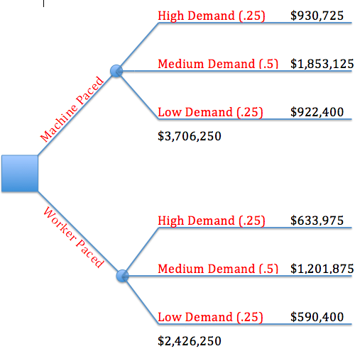

**Exhibit P4: Lead Time Cost for Suppliers ABC and P2**

|  |  |  |
| --- | --- | --- |
| **Lead Time (Days)** | **ABC LT Costs** | **P2 LT Costs** |
| 1 | $11.07 | $10.33 |
| 2 | $15.66 | $14.61 |
| 3 | $19.17 | $17.90 |
| 4 | $22.14 | $20.66 |
| 5 | $24.75 | $23.10 |
| 6 | $27.12 | $25.31 |
| 7 | $29.29 | $27.34 |
| 8 | $31.31 | $29.22 |
| 9 | $33.21 | $31.00 |
| **10** | $35.01 | **$32.67** |
| 11 | $36.72 | $34.27 |
| 12 | $38.35 | $35.79 |
| 13 | $39.91 | $37.25 |
| 14 | $41.42 | $38.66 |
| **15** | **$42.87** | $40.02 |
| 16 | $44.28 | $41.33 |
| 17 | $45.64 | $42.60 |
| 18 | $46.97 | $43.83 |
| 19 | $48.25 | $45.04 |
| 20 | $49.51 | $46.21 |

**Exhibit P5: Cost Analysis for Supplier ABC**

|  |  |
| --- | --- |
| **ABC** | |
| I | 18% |
| C | 75 |
| S | 500 |
| H | $13.50 |
| D | 7,664 |
| Q | 753.46 |
| TAHC | $5,085.86 |
| TASC | $5,085.86 |
| TAPC | $574,800.00 |
| TAC | $584,971.73 |
| TAC (With Safety Stock Holding Costs of $42.87) | $585,014.60 |
| LT (days) | 15 |
| Safety Stock | 3.18 |
| Total RP | 318 |

**Exhibit P6: Cost Analysis for Supplier P2**

|  |  |
| --- | --- |
| **P2** | |
| I | 18% |
| C | 70 |
| S | 90 |
| H | $12.60 |
| D | 7,664 |
| Q | 330.89 |
| TAHC | $2,084.58 |
| TASC | $2,084.58 |
| TAPC | $536,480.00 |
| TAC | $540,649.17 |
| TAC (With Safety Stock Holding Costs of $32.67) | $540,681.84 |
| LT (days) | 10 |
| Safety Stock | 2.59 |
| Total RP | 213 |

**Exhibit P7: Gantt Chart with Expected Times and Slack**

**Exhibit P8: CPM Network Diagram**

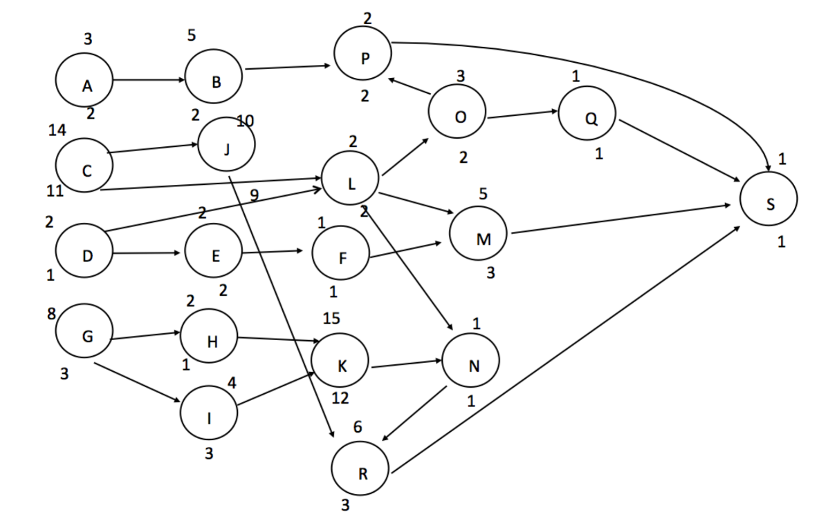

**Exhibit P9: Early Start, Early Finish, Late Start, Late Finish and Slack**

|  |  |  |  |  |  |  |
| --- | --- | --- | --- | --- | --- | --- |
|  | **ES** | **EF** | **LS** | **LF** | **LS - ES** | **LF-EF** |
| **Task** |  |  |  |  |  |  |
| **A** | 0 | 3 | 24 | 27 | 24 | 24 |
| **B** | 3 | 8 | 27 | 32 | 24 | 24 |
| **C** | 0 | 14 | 4 | 18 | 4 | 4 |
| **D** | 0 | 2 | 23 | 25 | 23 | 23 |
| **E** | 2 | 4 | 26 | 28 | 24 | 24 |
| **F** | 4 | 5 | 28 | 29 | 24 | 24 |
| **G** | 0 | 8 | 0 | 8 | 0 | 0 |
| **H** | 8 | 10 | 10 | 12 | 2 | 2 |
| **I** | 8 | 12 | 8 | 12 | 0 | 0 |
| **J** | 14 | 24 | 18 | 28 | 4 | 4 |
| **K** | 12 | 27 | 12 | 27 | 0 | 0 |
| **L** | 14 | 16 | 25 | 27 | 11 | 11 |
| **M** | 16 | 21 | 29 | 34 | 13 | 13 |
| **N** | 27 | 28 | 27 | 28 | 0 | 0 |
| **O** | 16 | 19 | 29 | 32 | 13 | 13 |
| **P** | 19 | 21 | 32 | 34 | 13 | 13 |
| **Q** | 19 | 20 | 33 | 34 | 14 | 14 |
| **R** | 28 | 34 | 28 | 34 | 0 | 0 |
| **S** | 34 | 35 | 34 | 35 | 0 | 0 |

**Exhibit P10: Crash Costs**

|  |  |  |  |  |  |  |  |  |  |
| --- | --- | --- | --- | --- | --- | --- | --- | --- | --- |
|  | Start | **I** | **G** | **G** | **G** | **R** | **R** | **R** | **JG** |
| CLNRS | 24 | 24 | 24 | 24 | 24 | 23 | 22 | 21 | 21 |
| CJRS | 31 | 31 | 31 | 31 | 31 | 30 | 29 | 28 | 27 |
| GHKNRS | 33 | 33 | 32 | 31 | 30 | 29 | 28 | 27 | 26 |
| GIKNRS | 35 | 34 | 33 | 32 | 31 | 30 | 29 | 28 | 27 |
|  |  |  |  |  |  |  |  |  |  |
| Cost |  | $750 | $800 | $800 | $800 | $825 | $825 | $825 | $1,300 |
| Cumulative |  | $750 | $1,550 | $2,350 | $3,150 | $3,975 | $4,800 | $5,625 | **$6,925** |

**Exhibit P11: X-bar chart for ABC supplier**

**Exhibit P12: Range chart for ABC supplier**

**Exhibit P13: P chart for ABC supplier**

**Exhibit P14: X-bar chart for P2 supplier**

**Exhibit P15: Range chart for P2 supplier**

**Exhibit P16: P chart for P2 supplier**

# Finance

## Overview

We recommend that PERSCON invest in the P911 project as we calculate a positive NPV of $16.92Million and IRR of 110%. If we invest in the project, our stock price will increase in value.

## Project β

To determine PERSCON’s overall beta we created a regression of our stock’s monthly returns against the S&P’s monthly returns over the past 5 years. The resulting 1.010 beta includes debt, yet for internal projects we want to analyze our response to the market without the debt factor. Our evaluation values the project on a cash-flow basis, and at the same time eliminates the additional market risk of debt. Our team added the monthly historical tax rate and debt-to-equity ratio, and then found the after-tax capital structure for each month. We averaged this number over the past 5 years, and unlevered the βL to a 0.884 βU.

For determining the project beta, the five revenue generating projects’ historic monthly returns were compared to the 5 year S&P returns. Then, our team weighted each project’s regression coefficient with respect to size. The result gave us a central tendency to calculate a relative sensitivity. Next, we took the relative sensitivity and multiplied by the βU to return the project betas. This leads to the sensitivity factor for every revenue generating project without the additional debt financial risk of the company. Finally, PERSCON’s analyst veterans estimate an average of two of the previous project betas for the current project beta being evaluated, resulting in a 0.799 new project β.

## Cost of Capital

Using the CAPM model, we found a discount rate for our project against the market returns for the same amount of risk. We factored in our project β and the equity premium of 5.5% that PERSCON uses. To find the risk-free rate, our team valued the yield-to-maturity of our company’s treasury data. Since our project is evaluated on a yearly basis, we converted the 73 day T-bill YTM into a yearly rate. This evaluates to a 3.024 rate that will serve as the lowest possible market investment risk. From there, we added in the equity premium multiplied by our project β to account for the higher required return that investors demand with our sensitivity to market risk. The cost of capital evaluates to 7.415%, depicting the external return needed for fair investments with the same amount of risk.

**Mutual Fund Opportunity**

When we discount the cash flows using the cost of capital, we account for returns PERSCON could have made in a fair market investment such as a mutual fund. We did not include an additional opportunity cost for our cash flows or NPV analysis, as the discount rate factors it out already.

**Liquidity Premium**

The team discussed a liquidity premium, and concluded that it should not be added to our cost of capital. The cost of capital already accounts for the risk of this project through project β and the equity premium. Additionally, the equity premium has shutdown risk already associated with the project and project β shows sensitivity in this risk-return model.

## Incremental Cash Flow & NPV

Our team decided upon a 41.40% tax rate based upon the most recent tax rate of 40.4% and an average 2.4% yearly growth rate. We believe this tax rate will give a forward-looking approach; however, we only took the average growth for one year as it will eventually plateau. This is the effective tax rate, and differs from the statutory tax rate. We used this tax rate for all calculations except for effective cost.

Initial Cash Flow

**Effective Costs**

We calculated the Effective Cost of the depreciable assets by discounting future tax saving benefits and net salvage value back to the present. This lowers the cost of the assets to $1.05Million.

**Non-depreciable Expenses**

The assets that are not depreciated will receive instant tax shield benefits, without needing to be discounted. This calculation results in larger savings than the Effective Cost and sums up to $1.07Million.

**Net Salvage Value**

According to our information, PERSCON can reclaim $0.31Million from equipment previously purchased. This becomes an opportunity cost for the firm, as the $0.31Million inflow will be lost if the project is pursued.

Operational Cash Flow

**Revenue**

Our figures for revenue come from the provided information. Stated renewal and sales growth rates contribute to the total revenue we analyzed. High revenues resulted from the growth in new sales on top of renewal revenue.

**Depreciation & Interest**

Through effective costs, we already account for discounted depreciation and any connected tax savings in the ICF. Interest does not affect operating cash flows. It is already accounted for when we discounted each operating cash flow back to the present in the Net Present Value calculation.

**Relevant Fixed and Variable Expenses**

Our team was given the variable expense rate and used the rate to calculate yearly variable expenses from total revenue. We received information about annual fixed operation expenses of $1.54Million.

**Side Effects & Opportunity Costs**

Our team calculated the after-tax cash flows of new product sales. After calculating the growing unit sales numbers, we found the net side effects of the other unit’s cash flows. We also realized the R&D will decline as a result of the project for the first two years. This will have a net effect on the cash flows because PERSCON will experience a decline in returns of other projects as a result of perusing P911 ERD.

## Project Conclusion

Taking into consideration all of the cash flows with respect to the cost of capital formed by our calculation of the β, we evaluate the project above the Security Market Line and as an investment with an advantageous Internal Rate of Return.

## Mr.Nimmo’s Concerns

Mr. Alan Nimmo,

We understand your concern for this project. While your estimates represent possible revenues and expenses, further analysis and adjustments are needed in order to estimate the value of this project for our company. Your projections of the project estimate over $6Million to launch it and only $0.5Million in annual returns with the project breaking even in 12 years. Our estimations are significantly more favorable with $16.9Million of created value with the project breaking even in year two. The difference in the two estimates comes from the methods used to evaluate the cash flows. Our method of valuation takes the estimated future cash flows from the project and brings them back to the present-day. Our team made adjustments in order to find the value created instead of using pure accounting methods.

The “financial big picture” is a little more complex than what your estimate suggests. Our method of valuation compares this project to what the market estimates to be the required return for a similar project with the same level of risk. We found the internal rate of return for this project to be 110.28% while investors require 7.41%. This makes the project extremely desirable, as it would create value for the company and its shareholders. Our team calculated this created value by taking all the expected future cash flows and bringing them back to what they would be worth in the present-day. This method is referred to as finding the Net Present Value of the project. Our team accounts for all expenditures and expenses differently than how you would find cash flows reported on our company’s income statement or statement of cash flows.

You estimated over $6Million would be needed to launch the project. This calculation included all previous and future spending. For our purposes of finding the value created by the project, not all of these costs are relevant. The costs that must be considered are the costs that are incurred only if the project is pursued and actually launched. Your estimate of the costs to start the project included the $1.2Million spent on R&D activities and $0.545Million spent on preliminary marketing efforts. These costs were already spent and would have the same effect on the company whether the project was pursued or not, therefore irrelevant when analyzing the project.

Only certain costs would be incurred if the project were pursued. These costs are relevant and should be accounted for while calculating the value created from the project. Your estimate was correct when it included the costs for non-depreciable assets and services because these costs would only be incurred if the project were pursued. Depreciable assets are treated differently. Our method took the tax savings that would be gained in the future and brought them back to the present. This calculation is called the Effective Cost of the assets and it is added to the cost of launching the project at an amount of $1.05Million. An amount of $0.455Million was spent on production equipment that could be used for the project. If the project is not pursued, the equipment could be sold for $0.31Million. This is treated as an opportunity cost and is calculated into the startup costs.

You estimate this project will only return $0.5Million annually. You are correct when you subtracted annual fixed and variable expenses from total revenue, but your analysis also takes into consideration depreciation and interest. The method our team used to find the value created already accounts for these expenses by bringing the costs back to the present-day. The tax shield savings from depreciation is already added when we find the effective cost of the depreciable assets. The interest expense is accounted for when we bring back the future cash flows to the present-day and calculate the value created from the project. Our team also calculated the effects this project would have on our other products and our R&D department. These effects are counted because they are only experienced if the project is pursued.

Although your estimates could potentially be what is stated on the income statement, it does not look at the “big picture” of the project. By calculating what value the project can create for the company we are then able to make a better decision about the benefits of the project. Our team calculated that this project could create $16.9Million for the company. We suggest that you pursue the project, as it will benefit the company as a whole and its shareholders.

We hope this information helped you understand our point of view on the project. Please feel free to contact us with any further questions you may have.

Sincerely,

Team Optimum

## Finance’s Value Added

Mr. Nimmo, you are absolutely correct that the financial industry caused the Great Recession. The financial professionals failed to do their jobs, and the entire economy suffered as a result. Finance focuses on risk and increasing value, usually in terms of cash. Leading up to the Great Recession, the financial world was on an out of control gambling rollercoaster. Picture going to a casino and winning many consecutive games in a row. You know the odds stack against you, yet you keep betting “all in” each time and winning. Why should you stop? You should not bet this much money at such a great risk, but you keep winning. Then, you lose a game. The money is gone, and even worse; some of it was a loan. That is what happened in 2008. The housing market went down, and the financial industry had doubled down on a bad bet. The professionals knew what they were doing and chose to keep betting.

Although if finance had recognized the risk associated with the bets, the professionals would have acted differently. Our financial team focuses on correctly placing bets. We account for risk and reward, always properly lowering the reward with regard to the risk. The more risk, the more we lower our perception of the reward. If you speed while driving on the highway and save 10 minutes, was the times saved worth the chance of getting pulled over by a police officer? Maybe, as finance will evaluate the risk and reward. If you are 50% certain you will be pulled over, then most likely you should not choose to speed. If the risk were .05%, then taking the risk might be worth it to get to work on time. We all take risks, and need to take risks in life and industry. Nobody would leave their house or build a new product if all risk was avoided.

Finance allows the economy to grow at a rate to let a civilized world flourish. PERSCON has publicly traded stock, granting us access to the cheapest money for borrowing. Many Americans set aside money for investing in a retirement account. When they retire, their investment will have grown into something far greater than if they had just dug a hole, hid the cash there, and saved up throughout the years. We only point this out because Americans investing in companies like PERSCON, invest in people like yourself. The products we sell cost a great deal for the company to manufacture. If we could only sell what we could afford at the moment, we would continuously run out of product to sell and never meet our full sales potential. The finance industry evaluates their trust in our sales ability and gives us money to create enough product. Americans invest in you and let you sell more of our products. If you generate more profit, everyone gets a return. We get more profits and, in return of letting us borrow money, pay the investors back with interest.

Ever since the Great Recession, the finance industry has to act more diligently than ever before. Our finance team analyzes investments and factors in the risk and return associated with lending out money. PERSCON has the trust of many Americans who invest in our company. Our financial team evaluates investments so that we only pursue beneficial investments to our shareholders and company. Without finance, we would invest in projects that may not return enough value. Finance compares investments and finds the ones which generate the most return for our company. We will only invest in the projects that will generate more value in comparison to the overall market. Finance takes into account all the stakeholders and evaluates the projects on a level playing field. The industry allows us to grow at a respectable rate.